

High Level Requirement

Sabre 2.0 – Order managment

Table of Contents

2. Document Control 6

2.1 Data Confidentiality Statement for this document 6

2.2 Versioning 6

2.3 Review Participants/History 7

3. Executive Summary 8

3.1 Purpose of document 8

3.2 High level description of project 8

3.3 Requirement statement 9

3.3.1 Out of Scope Areas of Business 10

4. Order Management Interfaces 11

4.1 Customer Service Interface 12

4.1.1 User types 14

4.1.2 Order Read Only Access 14

4.1.3 Order Approval Access 15

5. Order Creation 16

5.1 Overview 16

5.2 Order types 16

5.2.1 Regular Order – Business Rules 17

5.2.2 Pre-Order - Business rules 17

5.2.3 Discussion Points - Pre-order Management Issues 17

5.2.4 Re-Order management - Business rules 17

5.2.5 Discussion Points - Re-order Management Issues 17

5.3 Manual Order Creation 18

5.4 Website Order Creation 19

5.4.1 If PayPal and PayPal Credit selected: 21

5.4.2 If Credit Card, Debit Card, or Bank Transfer payment is selected: 21

5.5 Order Fields and Descriptions 23

6. Order Validation 35

6.1 Scope of Order Validation procedure 36

6.2 Order validation 36

6.2.1 Order data Integrity 37

6.2.2 General Order Validation - Business Rules 37

6.2.3 Payment Gateway Validation 38

6.2.4 Credit Card – WorldPay - Business rules 40

6.2.5 PayPal Business rules 40

6.2.6 Bank Transfer- Business rules 40

7. Requirement Specifications: Fraud Management System Requirements 42

7.1 Administration System Configuration 42

7.1.1 Requirement statement 42

7.1.2 Requirement scenarios 42

7.2 Fraud scoring 42

7.2.1 Requirement statement 42

7.2.2 Requirement scenarios 42

7.2.3 Fraud Check - Business rules 43

7.2.4 Risk Guardian Fraud Check 43

7.2.5 **Internal Fraud Check** 43

7.2.6 WorldPay Risk Setting Matrix 47

7.2.7 Risk Guardian validation authorization 48

8. Payment Management 49

9. Order Management 49

9.1 Definition 49

9.2 Order Status 50

9.3 Order Management Process Flow 53

9.3.1 Change Order Status – CS Agent 53

9.3.2 Order Approval – Order Manager 54

9.3.3 Requirement statement 54

9.3.4 Requirement scenarios 54

9.3.5 Initiate Fraud Check - Risk Management 54

9.3.6 Manage Orders with Issues – CS Agent 54

9.4 Order Process Flow List 56

9.5 Create regular order – website 57

9.6 Create regular order – CS Agent - Sequel 60

9.7 Create Pre-order – CS Agent – Sequel 61

9.8 Create Re-order – CS Agent – Sequel 61

9.9 Cancel an order 61

9.9.1 Cancelled Order - Business Rules: 62

9.10 Send order to Dispatch 63

10. Order History 63

10.1 Order history: email address 63

10.1.1 Requirement statement 63

10.1.2 Requirement scenarios 63

10.2 Order history: delivery address 63

10.3 Requirement statement 63

10.4 Requirement scenarios 63

10.5 Customer blacklisting & whitelisting 64

10.5.1 Requirement statement 64

10.5.2 Requirement scenarios 64

10.6 Bin check 64

10.6.1 Requirement statement 64

10.7 3rd party fraud prevention integration 64

10.7.1 Requirement statement 64

11. Reporting 64

11.1.1 Requirement statement 64

11.1.2 Requirement scenarios 64

11.2 Order Status Change (Manual and Automated) 66

11.3 Manage Pre-Orders 66

11.4 Manage Orders with Issues 66

11.5 Order Cancellation - Cancelling Orders: 66

11.5.1 Cancel whole order 67

11.5.2 Cancel line item on order 67

12. Returned Merchandise Authorizations (RMA) 68

13. Trade-Ins 69

13.1.1 Requirement statement 69

13.1.2 Requirement scenarios 69

14. Preset Email Samples 74

15. Requirement Specifications: Generic 74

15.1 Generic requirements 74

15.1.1 Requirement statement 74

15.1.2 Requirement scenarios 74

15.2 System integration 75

15.2.1 Requirement statement 75

15.2.2 Requirement scenarios 75

16. Glossary 75

17. Figures 75

18. Tables 76

# Document Control

## Data Confidentiality Statement for this document

This data confidentiality policy is intended to:

1. Protect sensitive company data
2. Support the communication of company data on a ‘need to know basis’

This policy is applicable to all information within and relating to the **High Level Requirements: Sabre 2.0 project**. Failure to comply with the policy may place the EXPANSYS group companies and subsidiaries, suppliers and clients at serious risk and/or result in financial loss. Failure to comply with the policy when handling data may be considered a disciplinary offence.

This Policy applies equally to EXPANSYS, PJ Media Limited, PJ Interactive and Data Select.

The confidentiality level of this document has been determined as Category 1 – Critical: This data, if lost or published outside of its intended audience will result in significant financial loss or reduction in the company’s ability to execute its mission. The audience for this document is limited to those listed below.

The business owner for the High Level Requirements: Sabre 2.0 project is Gary Challoner; all queries relating to the confidentiality should be directed to this person.

Intended audience

## Versioning

| Ver. # | Change Description | Release Reference | Date | Author |
| --- | --- | --- | --- | --- |
| 0.1 | First Draft | 0.1 | 160225 | NG |
| 0.2 | Updated with feedback from: | 0.2 |  |  |
| 0.3 | Updated with feedback, Second Review, by: | 0.?? |  |  |
| 0.?? | Signed off, Published | 1.0 |  |  |

1. Versioning table

## Review Participants/History

|  |  |  |  |  |
| --- | --- | --- | --- | --- |
| Title | Name | Review or  Signoff | Date | Comments |
| Document Owner (BA, TW) | Natalie Geary |  |  |  |
| Project Manager | Tom Freemantle |  |  |  |
| Product Owner | David McLean |  |  |  |
| Project Sponsor | Simon Trend |  |  |  |
| VP of Development | Ozkan Mustafa |  |  |  |
| Head of Development | Piotr Ignaczak |  |  |  |
| Customer Services | Taz Rose |  |  |  |
| Head of Sales | Brigid Cerelli |  |  |  |
| Head of Infrastructure | Razvan Draghichi |  |  |  |
| Head of ERP | Debbie Auld |  |  |  |

1. Review Participants

# Executive Summary

## Purpose of document

This document has been written to capture and explain the current requirements and processes of the Order Management system used at Samsung (referred to as Sabre 1.0), for the purposes of highlighting the requirements for the Sabre 2.0 project (the migration to Brandpath Commerce (BPC)), currently in development. The project is to replace like-for-like order creation, payment validation, stock allocation, invoicing, dispatch, pick and pack, RMA and refunds, and shipping processing. Whilst the functional results are to be maintained, the processes and software functions will provide a modern look and feel, streamlined back-end processes including easier system controls, less manual intervention, and a stable, scalable, solution, based on using Java, Sage X3, and new internal modules such as PIM, OMS, and ESOM (orchestration engine).

This document is written to capture the requirements and functionality of the Sabre 1.0 order processing system. It will provide insight into the areas which need discussion and agreement on the requirements to be obtained by the project development team and enable the project scope to be estimated, but it will not contain all of the detailed requirements for the solution.

The solution will evolve through evaluation and discussion of process compromises previously required due to prior software restraints and alleviated by current technology offerings and practices, as agreed upon during the development phase of the project.

A Business orientated High Level Design (HLD) document will be created by a BA/technical writer based on this document and discussion and agreement by key stakeholders.

A technology based HLD will be created by the Solutions Architect based on the requirements contained herein, the Business HLD, the agreements by key stakeholders, and any technology constraints encountered during the planning design stage.

The focus of this document is:

* To capture the current state of the Sabre 1.0 order management system.
* To enable a clear understanding of the benchmark business requirements and business rules to be met by the migration development project team.
* The means for review and discussion of business requirements to be evaluated for future requirements of Sabre 2.0 migration project (due to past constraints there are manual workarounds which may be relieved with new software approach).
* To state the comprehensive business requirements which will become the business side input towards the Technical HLD document, developed by the Solutions Architect.

## High level description of project

The Sabre 1.0 website is to be used as the reference site for creating Sabre 2.0 requirements, a like for like deliverable, following the same look, feel and user journey. The underlying benefits will be provided although the foundational platform on Sabre 2.0 will have current technical components with wider functionality and the potential to develop future enhancements.

Those areas of business determined to be out of scope will be identified (See 3.3.1 Out of Scope Areas of Business) and will not be included in this document deliverable. Efforts to identify and capture related data on these out of scope areas will be made for the purposes of review and possible inclusion in a follow-up phased approach to the software application, as this information comes into focus during research for this requirements deliverable.

## Requirement statement

The Sabre 2.0 site is to include the look, feel, and functionality of Sabre 1.0 as referenced in this section. Although the requirement is to provide a like for like solution, this does not prohibit enhancements where feasible with new technology and time permitting.

It is understood where aspects of the existing solution are not optimal or are under inherent technical system restrictions they should be called out for review and discussion. Such technical restrictions will be addressed in the development process of the Sabre 2.0 Order |management solution design with changes highlighted as replacement solutions or future enhancements, as agreed upon by the project sponsors.

Order management should follow the existing system regarding;

* Order Creation
* Web Site Order Creation
* Manual Order Creation
* Order Fields
* Order Approval
* Order Data Requirements
* Check Order data is valid
* Complete Fraud Check:
* PayPal Check
* Credit Card Check (WorldPay)
* Manage Bank Transfers
* Order Management
* Manage Pre-Orders
* Manage Back Orders
* Manage Orders with Issues
* Order Status Change (Manual and Automated)
* Order Awaiting Information
* Order In process
* Order Awaiting Payment
* Order is Expired
* Order is Cancelled
* Order Cancellation
* Cancel whole order
* Cancel line item on order
* Order Returns
* Return Merchandise Authorization
* Order Refunds
* Trade-Ins

### Out of Scope Areas of Business

The following are areas of business that are out of scope for this Business Requirements document:

* Invoice Creation and Order Fulfilment
* Receiving funds from the carrier back to the MOR (Manufacturer of Record); (this is covered in the Financial Support SOP)
* Managing the Pick and Pack of items for an order (covered in the Order Fulfilment SOP)
* Managing the Delivery and Failed delivery of an order (covered in the Order Fulfilment SOP)
* Substituting ordered items (swapping) (covered in the Product management SOP and Customer Services SOP).

# Order Management Interfaces

This is a sample of an Sequel Order processing Screen, with the various Buttons representing the activites of orders and inventory management. Each Button has it own collection of tabs relevant to the information surrounding the Button type activities. The Order Processing Button has a collection of Order Status tabs with the data fields pertaining to the relevant requirements for orders in that status. Each order status is described in this document in several areas including table data with descriptions, process flows for order creation, order processing and order issue management flows. In the following screen shot, the Order Processing Button has been selected, and the Tab “Unprocessed” selected. You can see the many areas where data can be entered or selected to fine tune the display, to locate a particular order, or group of orders, information about customer order and payment details, history, contact details, and to perform customer service activites.

* The screen is overly complex and needs to be broken down to logical and easily manageable user authorization controls and journeys in future. Each Button will be broken down and the details of the tasks and fields available will be detailed in the following pages.

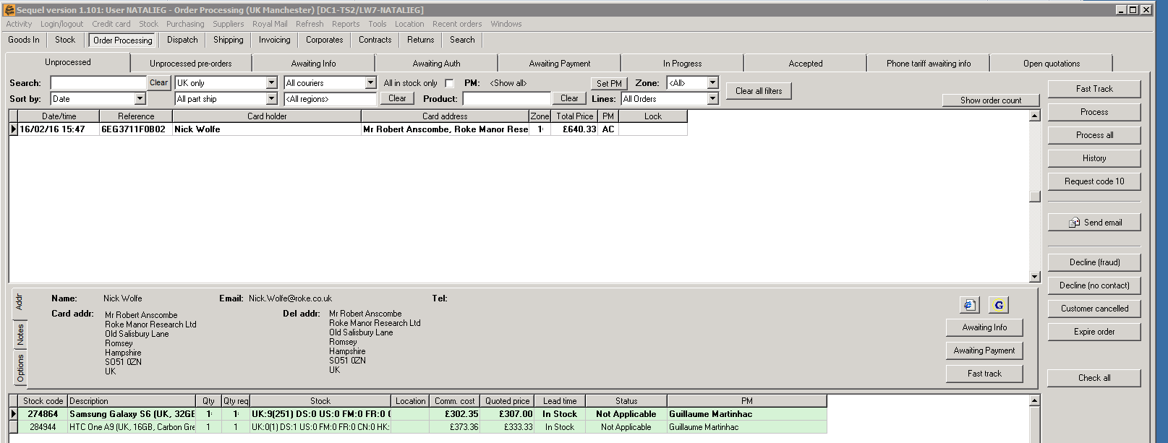

This is the Order Processing screen and associated buttons in two rows on top. We are seeing the Order Processing button with the associated order status tabs, and the “Unprocessed” tab selected. Note that orders can be displayed for orders involved in different stages, such as Dispatch, Shipping, Invoice, Returns, and search by order ID.

1. Sample Sequel Order Processing master screen.

## Customer Service Interface

Order flow is of particular interest to the CS Agent aspect of order processing and order management. The customer Service web interface is available using Sequel. There are several layers to the Sequel master screen, two rows of activities, 7 Status tabs with associated data fields and activities, 14 action buttons for order management, 3 side tabs for address display, Notes of past orders, and Options, which is used to determine which columns are displayed for orders displayed. All details of an order are accessible by selecting the appropriate activity button, pull down menu display parameters, and order status.

Here is a list of activities that the customer service agent can perform for orders:

* Fast Track
* Process
* Process All
* History
* Request Code 10 – used for AmEx Authorization code – out of scope
* Send Email
* Decline (fraud)
* Decline (no contact)
* Customer Cancelled
* Expire Order
* Check All
* Awaiting Payment
* Awaiting Information
* Note the right side of the Sequel master screen in the example on the following page for CS Agent activity buttons for order processing.

Here is a sample of what the Sequel customer service interface:

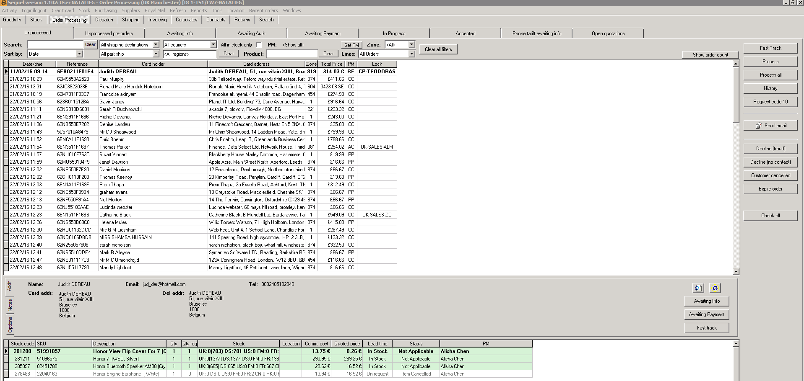

Order records displayed by date and order reference number, or by other selected criteria selected from pull down menus, buttons, or data input.

Orders can be managed by these action buttons.

Orders can be displayed by order status as well as by other search criteria

1. Sample Sequel Customer Service interface

Orders can be displayed or searched for by various criteria, including an order number, customer name, by product, location, date, and a combination of criteria. Once an order that requires an action to be taken is displayed, the CS Agent can use the action buttons on the right side of this screen to perform order management activities. Note the side tabs on the lower left side of the screen, where Notes can be entered, address information displayed (along with buttons for awaiting information, awaiting payment, and Fast Track status can be set for the order) and Options, where display column options can be selected.

There are 3 main types of administrative interfaces for the Order Management application:

* System Administrator interface used to configure system aspects, software updates, and other system related operational tasks (access restricted by authorization table).
* CS Agent interface used to view and to change order information for customers and to change order status (change order access restricted by authorization table).
* Order Management Approvers interface used to review and approve/decline orders after fraud check (order approval access restricted by authorization table).

### User types

There are four main types of system users:

| Type | Ability | Screens access |
| --- | --- | --- |
| Order read only user | The Order Read Only user can log into the system and see orders for the account(s) they have access to. They can see the data, but not make any amendments. | * Order search screen |
| Order approvals user | The Order Approvals user can log into the system and see orders for the account(s) they have access to, and add data, change status, and approve or decline orders. | * Order search screen * Order approval screen * Order details |
| Account administrator* | The Account Administrator can configure the settings for one specific account (e.g. add users or change workflows). | * System configuration screen * User access |
| System administrator* | The System Administrator can configure the settings for several accounts e.g. add users or change workflows. | * System configuration screen * User access |

1. System User Types

* Both the Account Administrator and System administrator user types will use interfaces or command line access to perform their duties, which are of scope for the purposes of this document.

*System administrator across accounts; (e.g., user type to be used by the implementation team).

### Order Read Only Access

#### Requirement statement

An order “Read Only” user can search for and view orders under their assignment. No changes to orders can be made by this type of user.

#### Requirement scenarios

1. The search options available are:
   1. Order status
   2. Order reference number
   3. Customer details
   4. Product details
   5. Order created date
2. The user can combine the different search option criteria (e.g., status and product details) to refine the search; no changes can be made to any data; viewing for informational as-is state only.

### Order Approval Access

An order “Approval” user can search for and view orders under their assignment and can make changes to the order as required.

#### Requirement scenarios:

1. Can search for an existing order, with the search options available:
   1. Order status
   2. Order reference number
   3. Customer details
   4. Product details
   5. Order created date
2. Can combine the different search option criteria (e.g., status and product details) to refine the search for an existing order.
3. Can create a new order of any type (regular, pre-order, and re-order), using the Sequel Enter Order screen. Can make changes to order status due to incoming requested information.
4. Can approve an order, based on business rules and following a fraud check.
5. Can change the status of an order.
6. Can send email to a customer.
7. Can perform a “Request Code 10” which is used to request an authorization code from AmEx – **not in scope**.
8. Can Fast Track an order, sending it straight to Dispatch, invoicing and fulfilment.
9. Can Cancel, Expire, or Decline any order, based on business rules, past orders, and suspected fraud.
10. Can override fraud alerts, if satisfied that the customer owns the payment type and is validated and authorized to use the payment type.

# Order Creation

## Overview

Orders are entered into Sequel by either the shop.samsung.com\uk web site or manually by a Customer Service Advisor using Sequel (Select Activity button, then Enter Order).

## Order types

Orders fall into three categories:

* ***Regular order***: It’s the standard type of an order that a customer creates from the web site for items that are available for order and dispatch immediately (products are already traded on the market). This is considered the standard type order, and is the basis for information contained in this document unless otherwise specified.
* ***Pre-order***: A method of allowing customers to order merchandise that is not yet released for free trade on the marketplace and provides a preferred place in the order fulfilment queue (first order in, first order to be shipped method). Once the Product Id (SKU) is made available for dispatch, all orders containing the Product Id (SKU) are changed from “Unprocessed Pre-Order” to “Unprocessed” and customer service must assure that the pre-order has been confirmed and authorized by the customer so it can proceed to fast tracked order completion.
* Pre-orders are placed in the order management system, but are not considered “real” orders because they have no stock to be soft allocated and can lack information regarding final sale price and release date. The actual sale price and release date can highly influence the customer’s final decision on whether to buy the product.
* ***RE-order***: These are orders created by Brandpath Order Processing or Customer Service Agents when a replacement has to be ordered for the customer due to failed delivery or broken. A Returned Authorization process is used to provide the customer with the means of returning the goods and for the warehouse to accept the returned goods into inventory quarantine/repair.

Regardless of how orders are entered, the overall process flow remains the same, with two exceptions: Pre-Order and Re-Order.

* **Requirement**: For a Re-Order, in which the customer service agent enters a replacement order at no charge to the customer, there is neither initial screening nor payment authorisation required at the Payment Gateway, since the customer service agent has clear contact with the customer and the items have already been paid for with the original order.
* **Requirement**: With Pre-Orders, the orders are in a state of effective “hold” because the stock is not available for allocation or dispatch. The orders remain in the status “Unprocessed Pre-Order” until the stock is made available for dispatch. When the stock is made available, all orders containing this stock are automatically changed to status “Unprocessed” and a customer service agent must contact each customer via email and verify that they still want to proceed with the order and payment choices are verified; the initial screen is performed at that time and any obvious issues with a payment type are handled at that time, although the orders continue through the established order flow process through to shipping/delivery.

### Regular Order – Business Rules

This is considered the standard type order comprising the majority of orders, and is the basis for information contained in this document unless otherwise specified. All business rules not directly specified as for pre-orders or re-orders apply to regular orders.

### Pre-Order - Business rules

1. Pre-orders are to be dealt as a priority in fulfilment, which is sometimes difficult depending on when they are released and because of heavy manual process.
2. All pre-orders must be processed according to their order characteristics.
3. A pre-order can only be processed once the stock item (ordered product) has been received and set as stock available and ready for dispatch.
4. All pre-orders must be processed before any other orders created, after the product was available. Pre-Orders should be fulfilled as a first ordered, first fulfilled basis (FIFO).
5. All pre-orders must be confirmed with the client when price and release date have been confirmed; the FIFO method is often hampered because the CS Agent must contact the customer via email and await a response, ensuring that the customer still wants to purchase the product, at the sale price, and can pay for it now, before putting the order through to dispatch. There are waiting times involved for some orders, and this inhibits the logical flow of pre-orders.

* Discussion point: if pre-orders are taken and the sale date and sale time fields are used and links to the incoming P/O (receiving) data base, emails or voicemails could be automatically generated as soon as the stock is received into inventory, perhaps speeding up the contact/approval process by a day or two.

### Discussion Points - Pre-order Management Issues

* Pre-Orders are a very heavy manual process that takes too long to complete, preventing the administrator to be reactive. At a minimum, the product offering price should be automatically set when the stock becomes available; this information must be reliable.
* **Because of all issues that can occur in pre-orders there is no reliable way to deal with them in mass.**
* Due to all constraints involved in this process, the first in – first out rule for orders is very hard to respect.
* It’s not possible to complete the parts of the order where products are available separately from the pre-order products.
* These orders are not to be processed in the previous days of the order being available, as cannot set the sub-statuses until the order status is changed to awaiting further information.

### Re-Order management - Business rules

* These orders can only be created by Customer Service or Customer Support (Processing) agents.
* Re-Orders must reference the original order information for financial reconciliation (re-Orders are no charge to the customer).

### Discussion Points - Re-order Management Issues

* **There’s no notification when these orders are approved, agents have to verify the notes each time they enter to confirm if it has been approved or not.**

## Manual Order Creation

**Requirement**: Customer Service Agents must have the ability to enter the three types of orders manually (Regular Order, Pre-Order and Re-Order). Currently this task is performed via selecting the “Activities” button on the Sequel master screen, and then “Enter Order” from the list of available activities.

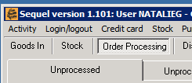

1. Sequel Activities button

After the “Enter Order” selection is made, the “Enter Order” screen displays:

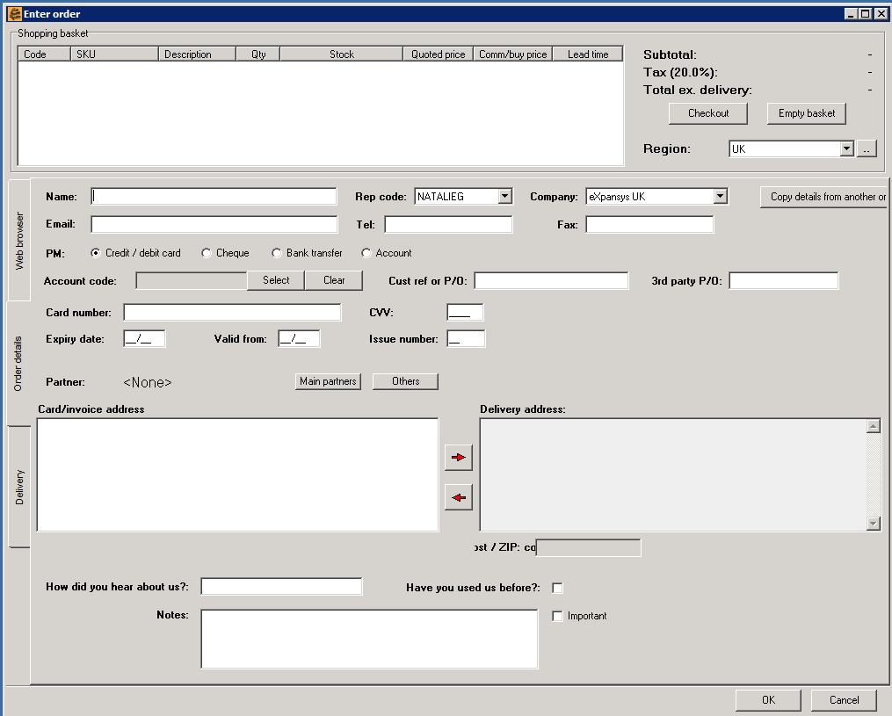

1. Sequel Enter order screen

The fields of data entry are almost the same as those required for users of the web site, with the exception being two added fields: Rep Code (the CS Agent (Rep) is selected from a pull down menu of finite selections) and the Company field, which indicates where the Rep works, has a pull down menu with finite selections.

* Note: I do not know if there is any validation between these two fields, or if the Ref Code selection dictates the company menu choices; no way to check this now with a live site; not a requirement.

See the section: 5.5 Order Fields and Descriptions for a comprehensive list of all the data entry fields, their descriptions of use, and the system uses and data repository where the information is stored.

## Website Order Creation

This is the shop.samsung.com/uk web site home page headers:

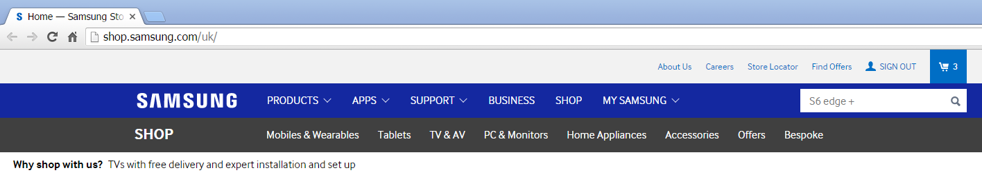

1. Shop.samsung.com/uk home page

This is the shop.samsung.com/uk web site Basket window:

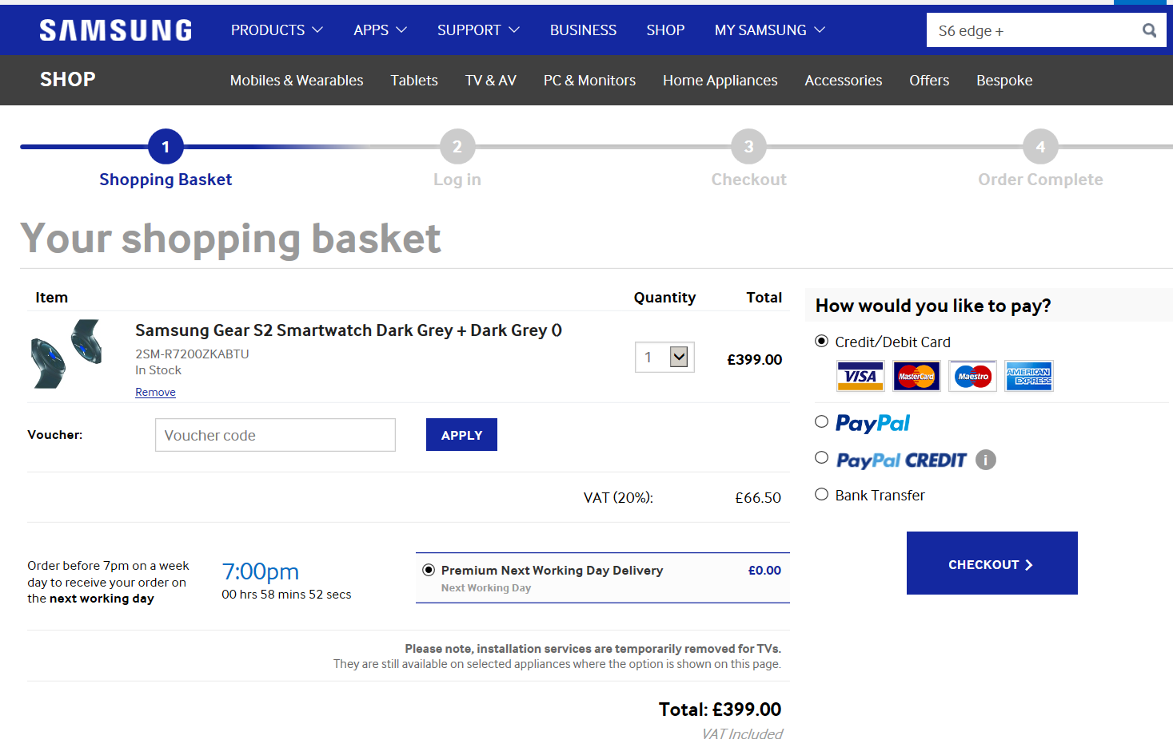

1. Shop.samsung.com/uk shopping basket

The e-Shopper makes adjustments to basket as required (changing quantities or removing items), optionally entering a voucher code, checking the delivery preference, and selecting a payment type, then checking the Checkout Button.

Regardless of what method of payment is used, the e-Shopper is asked to sign in to their Samsung Account or to continue shopping as a Guest.

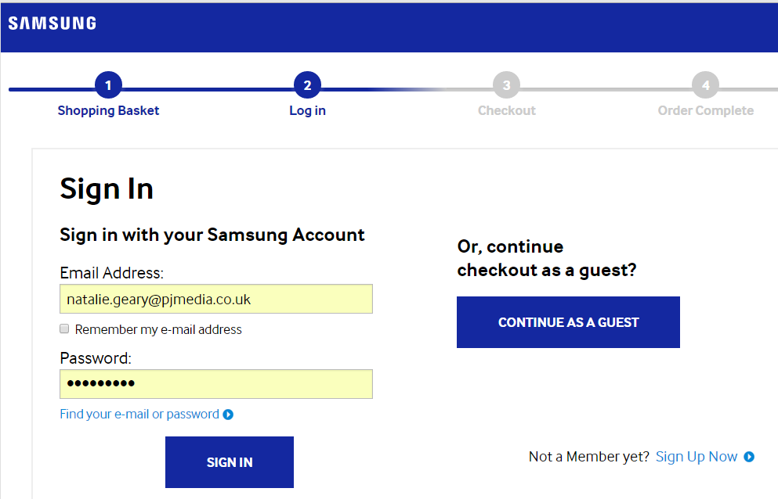

1. Samsung Membership Sign in Screen

If the customer has a Samsung Account, they enter their data and Sign in. This causes a cookie to be placed at the Samsung.com site and the first name of the customer is added to the Shopping Basket header greeting from the account hosted in the Samsung CRM. That is all the data that is transferred. It may also help the CS Agent in manually determining the initial screening for fraud prevention, as it shows that the customer is a prior customer, or that the customer chose to sign up for an account, which is also an option on this screen. If the customer chooses to become a new member, this screen displays:

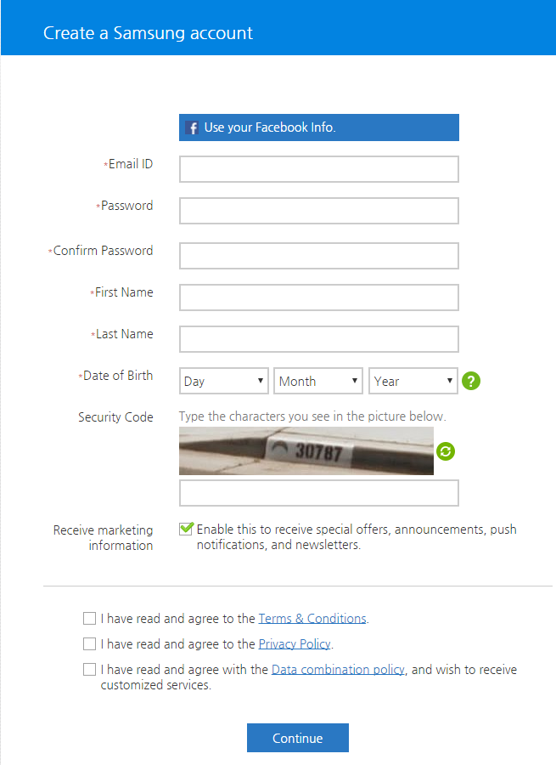

1. New Samsung Membership Account screen

The e-Shopper may also choose to shop as a Guest, and selects that option.

It does not affect anything on the following Checkout screens; there is no auto-population of fields from the CRM at Samsung, which hosts the membership account information. No information is passed either way except the first name on the Shopping Basket.

* Note: In future, it would be nice to have the billing and delivery fields auto-populated with information from the CRM Member Account record, to both ease the customer burden of data entry, and to avoid human error in data entry. Overrides to the delivery address allowed, asking for Billing cards to be added to the membership account adds another level of trust for the payment details.

### If PayPal and PayPal Credit selected:

If you selected to pay with PayPal or PayPal Credit Card, the e-Shopper is redirected to the PayPal site and login page for standard PayPal payment or to a PayPal landing page “Choose an offer today…” within the PayPal website. E-Shopper should follow the normal process for PayPal payments. This information is passed back to Samsung as approved or declined along with the delivery address details. Get the specifics on this!!

### If Credit Card, Debit Card, or Bank Transfer payment is selected:

If paying by credit or debit card, or bank transfer, the system requires the entry of customer billing and delivery data. The first Checkout screen displays where the e-Shopper enters their billing and delivery address details (ability to deliver to Billing address or enter another address for gifts or a work address is **required**). Contents of the basket to be purchased are displayed on the right, just above the Next State button and adjustments to the order are still possible (*adjustments loops through to Shopping basket, then Log in, then back to Checkout*.)

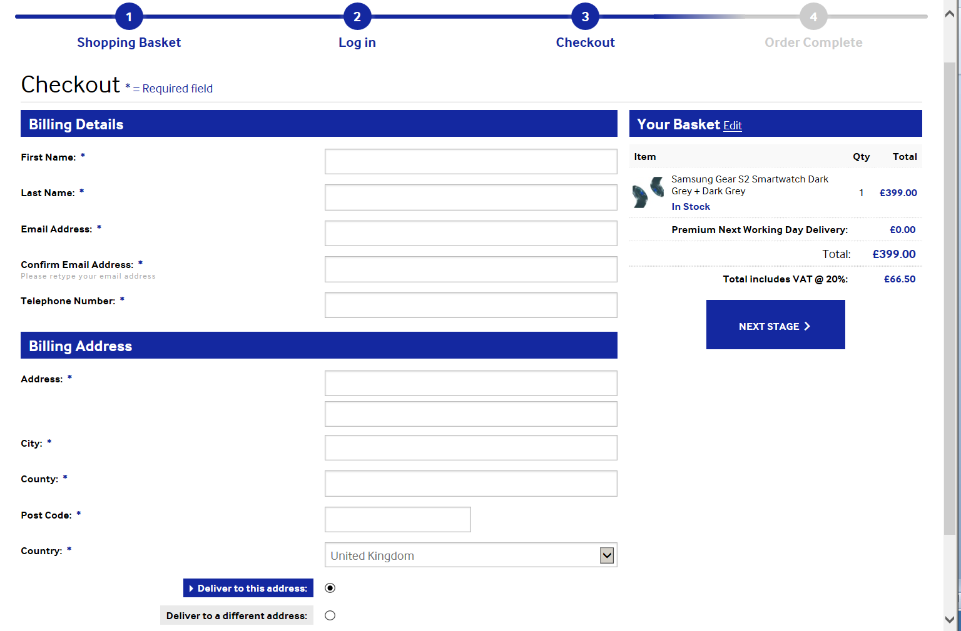

1. Shop.samsung.com/uk - Order Entry Checkout screen

Data is required and entered in the fields. See the section: 5.55.5 Order Fields and Descriptions for a comprehensive list of the data entry fields, descriptions of use, and system use and data repository.

After completing the order entry, the “Next Stage” button is selected, which triggers the Checkout Confirmation screen, where the order is actually confirmed and placed.

#### Credit or Debit Cards:

If Credit Card or Debit Card is selected, the following screen displays requesting the Credit Card number, name, expiry date and security code and proceeds with the payment for order. There are no adjustments at this point. System returns a Thank you screen with confirmation of ordered items and the Order Reference Number.

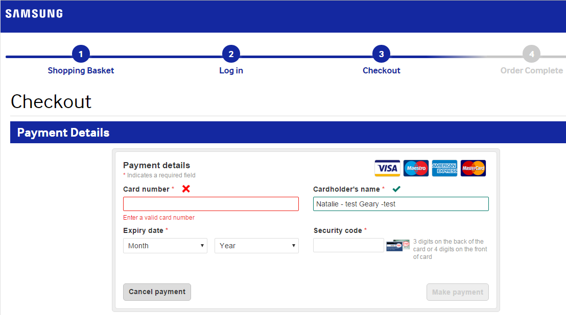

1. Credit/Debit card checkout screen

#### Bank Transfer payment:

After the Confirmation page where Billing and Delivery data was entered, a Bank Transfer information page is displayed, providing the bank transfer details and asking for a customer defined reference; this is a required field. This is a customer defined reference to be entered here and on the Bank Transfer reference line, for financial reconciliation purposes prior to releasing the order for shipment.

* At the time of this document first review, this issue with the bank transfer screen asking for the order reference number before the customer has it has not yet been fixed, but is scheduled to be integrated with the next bug fix schedule. This fix is mandated by Simon Trend, as the logical error created an increase in customer support calls, an increase in basket abandonment, and a decrease in sales using bank transfer.

## Order Fields and Descriptions

Every order has a collection of data entry fields within the Order Template; the data field can be assigned as a required field or an optional field, a radio button selection a pull down menu selection of finite choice, a specified format of numbers, letters, or alphanumeric characters, or a free text field. All orders have a prescribed collection of required data fields that must be validated before an order can be created.

There is a process in place, Initial Screening, which is performed by Sequel and validates that all orders comply with the minimum data requirements to insure that the order is placed by a legitimate customer, with the ability to pay, that the order can be fulfilled with stock, and that delivery can be assured. This process is defined in section 0

Order Validation.

The following table represents the current fields contains in an order record, noting required fields, with a description of the valid data accepted, syntax where applicable, and the data repository where the information is stored and how it is used in the system.

1. Customer Order data fields and descriptions

| Field Name | Definition | Data repository store |
| --- | --- | --- |
| ORDER TIMINGS | | |
| order_date | Date order was placed by e-shopper in format: DD/MM/YYYY | Sequel retains order creation date in order record. |
| order_status | Current Order Statuses are: Unprocessed, Unprocessed Pre-Orders, Awaiting Info, Awaiting Auth, Awaiting Payment, In Progress, Accepted, (Note: “Open Quotations” and “Phone Tariff awaiting info” are not used at this time). | Order record in Sequel; auto-process or by manual entry effects status change; There are also order sub-statuses that reflect processes and after process internal status changes. |
| order_approval_status | Currently not used per Debbie. | Currently not used per Debbie, but might have correlation to order status. |
| order_approval_date | Date order was approved by order validation processes in format: DD/MM/YYYY | Not currently used; placeholder; could be used for pre-order FIFO fulfilment. |
| order_approval_time | Time order was approved by order validation processes; numeric in format: 24 hour clock, hh:mm | Not currently used; placeholder; could be used for pre-order FIFO fulfilment. |
| sale_date | Date order, numeric, in format: DD/MM/YYYY reflects the date the sale was completed. | Order record in Sequel; Data in this field can be used for pre-order fulfilment processing, assuring FIFO order fulfilment. |
| sale_time | Time order was completed, displayed in the format: 24 hour clock, hh:mm | Order record in Sequel |
| rep_code | Used for manual order entry by CS, a pull down finite list of CR Agents authorized to create orders. | Order record in Sequel; maintained by CS dept./sys admin; may be used in customer service inquiries/management if issues with order or BI. |
| company | The company for whom the Representative works is selected from a pull down menu with a finite list. | Order record in Sequel, may act as a validation point with the Rep code. |
| SAMSUNG ORDER TYPES | | |
| sale_type | Three (3) types of sales: Regular, Pre-Sale or Re-Sale; alphabetic field, finite radio button selection. | Order record in Sequel; used in financial validation process for no charge re-Sale orders. |
| samsung_account | If the e-shopper logs in to their Samsung account, a cookie is placed on their CRM and the first name of the account holder is displayed on the basket header. If no ID, customer is shopping as “Guest”. | Customer records are stored in Samsung’s CMS DB, and at present only the first name is captured and parsed; nothing is stored. Why wouldn’t the Samsung account number be stored for future order validation? |
| guest | Either an X, yes shopping unregistered, or blank (Logged in to Samsung account. | null |
| type | Order Type; ? | Under investigation |
| PAYMENT INFO | | |
| firstname | First name of e-shopper; free text field, xx alpha character length. | Order record in Sequel; data must match payee billing details and is validated at the Payment Gateway during 3DS, AVS, CVC processes. |
| lastname | Last name of e-shopper; free text field, xx alpha character length. | Order record in Sequel; data must match payee billing details and is validated at the Payment Gateway during 3DS, AVS, CVC processes. |
| address1 | First line address of e-shopper; free text field, xx alphanumeric character length. | Order record in Sequel; data must match payee billing details and is validated at the Payment Gateway during 3DS, AVS, CVC processes. |
| address2 | 2nd line address of e-shopper; free text field, xx alphanumeric character length. | Order record in Sequel; data must match payee billing details and is validated at the Payment Gateway during 3DS, AVS, CVC processes. |
| address3 | 3rd line address of e-shopper; free text field, xx alphanumeric character length. | Order record in Sequel; data must match payee billing details and is validated at the Payment Gateway during 3DS, AVS, CVC processes. |
| city | City of e-shopper; free text field, xx character length. | Order record in Sequel; data must match payee billing details and is validated at the Payment Gateway during 3DS, AVS, CVC processes. |
| District (County) | County of e-shopper per Billing address, common abbreviated text (e.g., Bucks, Oxon); free text field, 5 alphabetic characters in format AAAAA. | Order record in Sequel; data must match payee billing details and is validated at the Payment Gateway during 3DS, AVS, CVC processes. |
| postcode | **Required**; Post code of e-shopper Billing Address; Total 6 alpha numeric characters in the format: “AAn nAA” . | Order record in Sequel; data must match payee billing details and is validated at the Payment Gateway during 3DS, AVS, CVC processes. |
| tel | Contact telephone of e-shopper Billing phone number of record; total 11 numeric characters, format: nnnnn nnnnnn | Order record in Sequel; data must match payee billing details and is validated at the Payment Gateway during 3DS, AVS, CVC processes. |
| email | **Required**; email of e-Shopper; standard email format: (unique) alphanumeric-ID@domain name.extension | Order record in Sequel; flows to courier component. Required as verified contact point with e-Shopper and used by Customer Service for all customer contact issues. |
| merchant_ref | Merchant Reference identifier; provided by Payment Gateway, a token not an identifier, used to identifier the Payee ID (recipient) for the disbursement of monies collected from order transactions. | This is under investigation |
| payment_method | Finite options: PayPal, Credit card (World Pay), Bank Transfer; Format: radio button selection | Order record in Sequel; selection triggers the Payment Gateway processes 3DS, AVS, CVC or PayPal processes as appropriate |
| card_type | Not currently used; can be used for Card issuer name “Visa”, “Master Card”. | *Currently blank* |
| card_no | PAN #, Partial capture, first 4 and last 4 # of credit or debit card, used for customer service order/payment reference tracking for e-shopper; numeric, stored in format: NNNN *space* NNNN | WorldPay CC only; Order record in Sequel; used for payment validation at Payment Gateway; ERP for financial reconciliation prior to dispatch, and BI. |
| exp_date | Expiration Date of Credit Card used, numeric in format MM/DD. | Not retained in DB. Captured & parsed, WorldPay only; sent with card name and number to payment gateway. |
| vps_auth | Value Per Sale Authorisation Code, a unique transaction numerical identifier, single use only, refers to the amount authorized + 10% credit card and 15% PayPal increase to total sale for shipping cost variances. | Payment gateway data, added to Order record in Sequel. Used to settle dispute if payment issue occurs. |
| trans_status | Transaction status: declined, accepted, approved?TBD? | Under investigation TBD from payment gateway |
| AVS | Address Verification System; Used in WorldPay credit/debit card validation process with 3DS and CVC process to verify the billing address matches record. | WorldPay verification process performed at Payment Gateway, details added to order record in Sequel; |
| 3DS | Validation method for WorldPay (credit/debit cards) if passed returns a Pre-Authorisation code (pre-auth) which verifies authorisation and insures (seller) against fraud loss for items on order (minus shipping costs). | WorldPay verification process performed at Payment Gateway, pre-auth code parsed and added to order record in Sequel; |
| cvc | Card Verification Code: is a credit card security feature present on back of physical card, used when the card away from POS. Numeric, format is 3-digit code specific to the card, not the card holder; varies with issuance of new card. | Captured and parsed at Payment Gateway – World Pay only – used with 3DS and AVS for initial validation, front end screen. |
| rg_score | Risk Guardian Score: used to score risk of shipping order; Risk Guardian is a transaction advisor; Policy in contract between RG and company to cover/resolve fraud. Back end process returns GS Score formulated by various investigative processes, Numeric, format is: nnn; value schema derivatives are proprietary. | Not used post-authorization at present. |
| ORDER DETAIL | | |
| order_no | A unique system generated order tracking number used inclusively within the system. Alphanumeric in format: 3 groups of 4 characters separated by hyphen (-); example: 6291-5512-E170 | Order record in Sequel, flows to ERP for order fulfilment, tracking, shipping and the courier component. |
| original_transaction | This is used for Re-Orders entered by CS Agent; used for re-order validation/ reference; consists of the original order number plus the original VPS auth code. | Order record in Sequel; validation of the previous order payment gateway process completion for Re-Orders; manually checked financial reconciliation reference; used in payments reconciliation and order error BI. |
| linenum | The associated order line number with each line containing a single product code/SKU; numeric, values up to nnn. | Order record in Sequel. Used for order fulfilment/validation, and customer service in ERP. |
| qty_shipped | **Required**; total quantity of items shipped to e-Shopper. | ERP captured at order fulfilment/validation, updated to Order record in Sequel and courier component for delivery. |
| material | **Required**; Manufacturer’s SKU for individual item for sale; synonymous with product code in Salvador; product codes matched in SKU reconciliation table in Salvador. | Product and product Offering records in Salvador. Flows to order records in Sequel and ERP for order fulfilment and validation. |
| material_description (Title) | **Required**; Title of product; alpha numeric text field providing the text string description of the SKU, often with specification details as warranted (e.g., size, capacity, colour) | Part of product SKU record and product Offering record in Salvador; flows to Order records and ERP for fulfilment and order checking. |
| ean | **Required**; European Article Number a 13 digit (12 data and 1 check), barcode standard identifier, defined by standards org. “GS1”. *Also known as Global Trade Item Numbers (GTIN);* numeric*,* format: left group: digits 2-7, with first digit either odd or even (parity schema), right group: digits 8-13 (digit 13 is the check digit). | Part of product record and Offering record in Salvador, flows to order record and ERP for order fulfilment and validation. |
| sku_type | **Required**; Registered owner of the SKU # (Stock Keeping Unit); e.g., Samsung; alphanumeric, free text field. | Part of the product record in Salvador. |
| sku_category | Manufacturer defined intelligent schema; format: alphanumeric; matched in ERP reconciliation table to match with Salvador Product Codes. | Part of product record in Salvador; added to order record, passed to ERP for order fulfilment. |
| series | An alphanumeric descriptive delineator to distinguish between versions of a product. | Product record and Product Offering record in Salvador, flows to order record in Sequel and ERP for order validation. |
| size | Dimensions – the physical dimensions of the SKU, in metric units, height, length, depth; used for warehouse storage planning and picking and shipping tasks; numeric in metric cm. | Product record in Salvador; physical dimensions of SKU used by courier component for pickup/delivery planning. |
| capacity | Data indicating capacity for internal storage for phones (e.g., 4GB). | Product record in Salvador; Used for smart phone only now. |
| colour | Colour of item ordered | Product record in Salvador, flows to order record in Sequel and ERP for order fulfilment/ validation. |
| serial_number | If SKU is tracked by serial number, a unique and specific serial number is included in the order line item; the serial number and location is selected by an inventory pick list generator, which performs pick list creation. | During pick pack process Picker scans serial # at picking point and that data is added to order in Sequel and ERP. |
| currency | **Required**; All order and product values are in Great Britain Pounds or “£” | Product and Product Offering records in Salvador, Order records in Sequel and ERP for orders and back end reporting. |
| rrp_unit | **Required**; Recommended Retail Price per unit; manufacturer provides as baseline pricing; used as the basis for marketing a discount, e.g., “10% off RRP” but still up to Offering to determine price. | Product record in Salvador. |
| price_discount | How does this interact or vary from an offering or a promotion? | current line item discount. X3 does it better - WIP – TBD Debbie and Oz |
| sold_price | **Required**; The actual amount charged the e-shopper for each item on order (net amount minus discount); numeric, format GBP, £nnnn.nn | Product offering record in Salvador, Net offering price minus discounts applied, as calculated in Sequel during order processing; flows to ERP for payment gateway validation and BI. |
| net_amount | **Required**; Net amount charged e-shopper for ordered items, not including extra fees and charges for VAT; numeric, format £nnnn.nn | Product offering record in Salvador, flows to Order record in Sequel, used by Sequel in calculating order total, used in ERP for payment gateway validation and invoice generation. |
| tax_amount | **Required**; The value of VAT charged the e-shopper for this order (in GBP £) numeric format £nnn.nnn ?? dispute as to number of decimal points used in calculations – must match Samsung’s, also calculated on a per line item or total order basis?? | Calculated in order processing added to Order record in Sequel; VAT required at ERP for payment gateway validation and invoice generation and reporting; also back end for VAT collection reporting. Under investigation whether line item VAT or total order VAT is to be used – can affect calculated totals as will # of decimal points used in calculation – conflict between Samsung and our collected VAT totals; issues surround whether VAT would be held in ERP – no reason per Oz, awaiting info from X3 – Debbie and Oz – next few days; |
| total_amount | **Required**; The total amount of the order (in GBP £) charged when combining unit price and applicable VAT for all items. | Order record in OMS; parsed to ERP for payment gateway validation and invoice processing; required at back end for BI reporting |
| discount_code | If a discount code was used (a **voucher** – single use, or **promotional code** – multi users multi use – number of uses (finite by total number allowed and end date), 6 digit alpha-numeric format. | Product offering record in Salvador; order record in OMS, used by ERP in payment gateway validation and flows to invoice; back end data required for reporting/BI marketing. |
| discount_description | A description of the discount applied; From seller: type, quantity, product, discount details, regions, start/expiry date, code (generated or specified), and additional notes. | Product offering record in Salvador, flows to order record in Sequel; used for back end BI marketing analysis. |
| delivery_option | A finite list of radio delivery options; courier under review - possibly DPD and UKMail. No cost for delivery | Options in Product record in Salvador, selection in order record in Sequel, flows to invoice and courier component. |
| installation | Installation type, finite selection per product (wet-plumbed, dry - in house, curb side, electrical connect, other); No installation costs | Installation options in product record on Salvador; Order record in Sequel indicates selected install, which flows to invoice and courier component. |
| scrap_removal | Yes or No; If old item is to be removed and replaced, e.g., refrigerator. No costs to e-shopper. | Order record in Sequel, flows to invoice and courier component. |
| How_did_you_hear_about_us | Used for CS entered orders, not website; Free text line, alphanumeric, used for marketing/BI reference purposes. | Optional, included in the Order record in Sequel. |
| Have_you_used_us_before? | A check box used when a CS order is entered; value is checked or not checked. | Order record in Sequel. Entry for CS manual Orders; may be used when performing the internal validation check for past orders/ background validation. |
| Notes | A free string text box for notations about the order or customer. Xx character capacity. | Order record in Sequel. |
| Important | Check box used when order entered by CS Agent indicating that the associated Notes text box contains important information. | Order record in Sequel. |
| returns_reason | Input from the Customer Service Agent who authorized the return; codes are finite and maintained by CS dept. and used for BI. | Legacy not in use |
| item_div | Do not know how used, investigation determined not in use. | Legacy not in use |
| SHIPPING INFO | | |
| pod_date | Proof of Delivery; the date the order was delivered; Format DD/MM/YYY. | Pushed from courier component to order record in Salvador. |
| consignment_id | Courier tracking reference identifier. For consigned goods, the consignment identifier for this product; unique identifier e.g., “PBEF9198053022” | Pushed from courier component to order record in Salvador. |
| tracking_url | The URL used to track the shipment of the product is uploaded to order record and also included in email to e-shopper; | Pushed from courier component to order record in Salvador. |
| ship_code | Shipping code for courier, format ?? | Pushed from courier component to order record in Salvador. |
| firstname2 | **Required**; First name of delivery recipient; ability to change receiver’s name from Billing Addressee for gifts. Free text field, xx character length. | Order record in Sequel. Can be used in fraud prevention processes; it is not validated against billing information. |
| lastname3 | **Required**; Last name of delivery recipient; ability to change receiver’s name from Billing Addressee for gifts. Free text field, xx character length. | Order record in Sequel. Can be used in fraud prevention processes; it is not validated against billing information. |
| address14 | **Required**; first line of delivery address; ability to change from Billing address for gifts. Free text field, xx character length. | Order record in Sequel. Can be used in fraud prevention processes; it is not validated against billing information. |
| address25 | 2nd line of delivery address; free text field, xx character length. | Order record in Sequel. Can be used in fraud prevention processes; it is not validated against billing information. |
| address36 | 3rd line of delivery address; free text field, xx character length. | Order record in Sequel. Can be used in fraud prevention processes; it is not validated against billing information. |
| city7 | **Required**; City of delivery address; ability to change from Billing address for gifts. Free text field, xx character length. | Order record in Sequel. Can be used in fraud prevention processes; it is not validated against billing information. |
| district8 | County of delivery address; ability to change from Billing address for gifts. Free text field, xx character length. | Order record in Sequel. Can be used in fraud prevention processes; it is not validated against billing information. |
| postcode9 | **Required**; Post code of delivery address; ability to change from Billing address for gifts; 6 alpha numeric characters; AAn nAA format. | Order record in Sequel. Can be used in fraud prevention processes; it is not validated against billing information. |
| tel10 | Contact telephone of e-shopper or delivery recipient; total 11 numeric characters for UK, no spaces or special characters. | Order record in Sequel, passed to Courier component for delivery. |
| email11 | **Required**; email of e-shopper must be valid or order is cancelled. | Order record in Sequel, pass to courier component for delivery. |
| marketing_pref | Either yes or no opt-in for future marketing. | Aspect of customer record in Samsung Customer DB; cookie on Ssamsung.com used to acquire customer record data. |

# Order Validation

The validation process is automatic and consists of checking all orders received from the web store and those entered manually by a CS Agent. Orders are checked by several data validation methods and fraud checks before shipment. The validation methods vary depending on the payment type selected, but all are screened for data entry errors and potential fraud activity.

* Orders with errors entered through the web store are accepted instead of rejected because of the high volume of orders that are entered erroneously but can be resolved via customer service interaction with the customer, resulting in a sale. An average of 30% of web based orders contains errors which are fixed with manual order processing by customer service.
* Sequel report #1342 identifies order errors and resolved orders error.

## Scope of Order Validation procedure

The Order validation process consists of three parts:

* Data integrity: ensure the order meets the established business rules for data syntax and required field data entry (performed at Payment Gateway).
* Payment Validation: ensure the accuracy and validity of order billing data against of billing record data for payment type selected. Payment validation processes at the Payment Gateway – 3DS, AVS, and CVC).
* Fraud check: assess whether the order presents no or minimal risk of fraud (Risk Guardian – RG Score and internal fraud check processes). (See 6.2.11
* The scope of this procedure is:

The validation procedure does not cover:

* Receiving funds from the carrier back to the MOR, this is covered in the Financial Support SOP.
* Managing the pick and pack of a product, this is detailed in the logistics SOP.
* Managing the delivery and the failed delivery, this is detailed in the logistics SOP.
* Swapping an item on an order for another item, this is detailed in the product management SOP and the customer services SOP.

The following areas are covered in this document as they related to order management, not the validation process or financial reconciliation processes involved in their execution.

* Returns of an order, this is in a separate SOP, except for the part that it’s handled by Customer Support.
* Re-Orders and Pre-Orders which are covered in Customer Service SOP.
* Managing a refund, this is detailed in the financial support SOP.

## Order validation

The data in every order created in the system needs to be validated before the order can be accepted for processing. Validation includes ensuring that customer billing, delivery and payment information is accurate and meets field usage and syntax requirements, and that the ordered product information is accurate. Validation is performed before the fraud check processes. There are two validation processes:

* The **Payment Gateway** (Initial Screening) process is performed on all PayPal and Credit/Debit card transactions. Processes are performed by either:
* PayPal for their orders (a site specific validation process exclusively for PayPal transactions, which returns a Transaction ID and delivery address and phone number if the order passes, or a failed notification if it fails.
* WorldPay for credit and debit card transactions, immediately after the Make Payment button is selected; screening process consists of the combined 3rd party processes:
* **3DS** (“validated by Visa”),
* **AVS** – Address Validation System, and
* **CVC** - Card Validation Code.

Together these three processes comprise the WorldPay validation of all credit/debit card orders.

* WorldPay is set to reject and automatically cancel an order that fails the AVS or CVC checks.
* WorldPay will return an authorization code for orders that pass validation and their fraud check processes and return an authorization code.
* WorldPay authorization code is proof that the order passed the WorldPay validation process and insures the order from fraud loss, indemnifying the merchant (seller) from financial loss for the total order amount less any shipping costs.
* **Internal CS Agent screening**: Any fields of data that are missing or contain partial or wrong information flag the order and a CS Agent will contact the customer and work to remove all issues; the order status changes depending on what information is required from the customer (e.g., awaiting information, awaiting payment).

### Order data Integrity

The integrity of order data entry is first addressed at the Payment Gateway. Each required field is screened to ensure it has been addressed and contains the proper syntax and length of characters, **although all required fields can contain errors while the order is in the Unprocessed status except the email address field**, which is the minimum actual required data, as it is required for customer service to use to contact the customer and help complete the order. All the fields contained in an order, the requirements, and where the data is used are represented in the table, “Table 2) Customer Order data fields and descriptions “.

After the order has been completed, with or without the assistance of the CS Agent, it is still scrutinized at the Payment Gateway for payment detail validation and fraud check processes.

### General Order Validation - Business Rules

1. The minimum customer contact information against an order is a valid email address; a phone contact is not required.
2. PO Box addresses are not a supported delivery address, they are deemed an unsafe method of delivery, as the delivery cannot be secure nor signed for and no secure proof of identity is required to rent a PO Box.
3. At minimum a single item or service must be included in the order.
4. If the payment method is bank transfer and there are no errors on the order then Sequel will automatically send the “bank transfer details” email and set to order status: “Awaiting Payment.” (*See the section Standard emails and templates section for examples.)*
5. If the payment method is credit card and the order amount is less than £100 and the order passed the Payment Gateway (3DS, AVS, and CVC screens), then Sequel will automatically fast-track the order, triggering the invoice and sending the order to the warehouse.
6. All orders in awaiting payment, awaiting authorization and awaiting information should be checked every day by its assigned CS advisor to see whether they can be resolved, with follow up every two working days.

* Note: Automated ageing should be explored for future development and implemented ASAP, as there is currently no was to catch an order that has been lingering and stock is soft allocated at the Shopping Basket add action, tying up stock unnecessarily for up to 10 days.

1. An order cannot stay in an “Awaiting…” (info, payment, cc authorization) status more than 3 days without any contact with the customer to rectify the issue. Orders in a hold status retain a soft stock allocation hold on stock, thus preventing the stock to be available on the website for new orders.
2. After 3 days in a hold state (Order status Awaiting info, payment, or auth), a reminder Email will be sent to customer.

* After 3 attempts the order status is set to Expired;
* After 10 working the order status is updated to Cancelled.
* If no response from customer in 3 weeks’ time, the order is deleted from the system.
* If customer responds before the order is purged and wants to proceed with order, it can be reset as Unprocessed again.
* At present, awaiting information and authorization, and awaiting incoming stock and late incoming P/O’s have to be constantly monitored to avoid order cancellations. Point for discussion, possible to link incoming PO data and receivables to order management interface.

1. If an authorization to deliver is refused by WorldPay fraud check or Risk Guardian or Internal fraud check, then payment by other credit card will not be accepted, due to the risk of fraud. Payment method must be changed to bank transfer.

### Payment Gateway Validation

At the Checkout stage, the Initial Screening process takes place at the Payment Gateway. These are the required fields that are validated by the Payment Gateway screening process:

* **First and last name** (this will be validated against the payment data reviewed in a later step.
* **Billing Address:** (number, street, county or region, post code); Billing address must match payment type record address in order to pass the validation process. P.O Box is acceptable for Billing Address, need not match Delivery Address.
* **Delivery Address:** (number, street, 2nd line address is optional, county or region, post code); Delivery and Billing Addresses can be different; P.O. Box is not acceptable for delivery address, must be physical address.
* **Payment Details**: select type of payment and enter relevant data.
* **Contact information**: a valid email address must be provided.
* **Item**: At least one product or service must be selected for an order and the stock must be available for soft allocation.

1. The Payment Gateway validation process includes third party validation processes, WorldPay (3DS, AVS, and CVC for credit and debit card transactions). This process also confirms that the required fields contain data in the proper syntax and that there is at least one item or service ordered. If any data is missing, the order record status is kept at “Unprocessed” and awaits intervention by a CS Agent).

* PayPal has their own internal processes and returns Transaction IDs for validated orders and the delivery address derives from the PayPal account the customer uses.
* Orders with errors or omissions **are not rejected**, as approximately 30% of website orders contain errors. By accepting the orders on a hold basis (status “Unprocessed”), the company has an opportunity to keep the sale by using CS Agents to make order corrections via manual order entry methods, rather than losing the sale by rejecting the order at the web site.
* If the order has issues with required customer information fields, the order is placed in status: “Awaiting info”,
* if the order is waiting for credit or debit card authorisation, the order status is “Awaiting Auth”,
* If the order is waiting for a bank transfer to clear, the order status is “Awaiting payment”.
* A CS Agent makes contact with the customer using one or more standard emails stored in Sequel in an attempt to resolve data requirements issues and process the order. See the Section: 8 Preset Email Samples to view the contents.

1. If an issue with any order data occurs, the order status is kept as Unprocessed, and an alert is sent to the CS team.
2. The CS Agent will assess the needs for information and send one of a series of prepared email templates, populated with customer specific information, requesting the required information.
3. The order status will be changed to reflect the required information needs (e.g., Awaiting Information, Awaiting Payment, Awaiting Authorisation), and remain in this status until the situation is resolved (the order cannot progress until the required information has been gathered and validated).
4. The CS Agent will regularly check on these orders on hold and if no further response from the customer after 3 days, the order can be cancelled,

* If the order contains errors that the CS Agent cannot resolve, the order is cancelled.
* If the order contains missing information that the CS Agent cannot rectify, the order status is changed to Declined – missing information.
* If the customer does not respond within 3 days, the order status is changed to Expired. Should the customer contact CS, the order can be revived, with an order status change to Unprocessed, and it will proceed like a new order.
* The aging of orders on hold is not currently monitored by internal process, it is totally manual and varies according to how busy CS Agents are, customer history, order volume, and other factors, so the ageing rules are lax and vary between 3 days to 10 days to expire orders and from 10 days to 3 weeks for cancelled and purged final resolution; an order can become lost in the system indefinitely. There are no formal order ageing processes, only CS practices, but this is an area that canand should be included in future features.

1. If the order details have been entered correctly, and passed the Initial Screening Payment Gateway validation, a **pre-auth code** is returned by WorldPay and added to the order record, a 3 day hold on the funds is initiated, although no monies are transferred, the stock is placed in a soft allocation, and the order then progresses to Risk Guardian (for credit and debit cards) and internal fraud check for both credit cards and the bank transfer process.

### Credit Card – WorldPay - Business rules

1. If the credit card check fails the fraud check, then only payment via bank transfer will be accepted. Process team will send an e-mail to customer advising him/her that they cannot pay with a credit card. A note will be added inside the order saying “BT only”. A customer services agent will contact the customer to offer him this option if needed (see the customer services SOP).
2. The order must be delivered to the person named on the debit card or credit card. Except for when enough positive identity has been provided to allow delivery to work address or as a gift; up to the Order Approver to determine enough proof to demonstrate payment method ownership and delivery recipient authentication. See below:.

* For orders being shipped to work addresses, the accepted items which provide proof of work address are one of the options listed below:
* Pay slip
* Business card and email from work email address (company name must match delivery address)
* Proof of link of customer with the company (e.g., details of the person on the company website0.

1. For security reasons, the threshold for the maximum amount accepted by credit card payment is fixed to £1000. Payments by bank transfer are compulsory for amounts exceeding £1,000. Only the **Process Team can decide whether or not this rule will be adhered to**, on an order by order basis, due to the risk to the business of the credit card payment becoming a chargeback. B**y law the customer can perform a chargeback up to 13 months after the payment was made.**

### PayPal Business rules

* PayPal returns a Transaction ID and the delivery details when an order is validated by PayPal.
* When delivering a PayPal order, it must be sent with a Tracked Delivery method in case any dispute occurs, as proof of delivery must be provided for any case to be disputed.
* POD is available within 24 hours.

### Bank Transfer- Business rules

* The amount received in the bank account must match the order amount – this is managed by the financial reconciliation team daily, by hand, using the reference identifier the customer has entered on the web site reference field, and included on their bank transfer details.

The visual process flow for order validation is:

1. Order validation process flow

Payment Type

(Missing valid email address)

Merge

Yes

Payment Details

No

Order cancelled

Name & Delivery address details

(Partial Complete)

Yes

Required data provided

(Data Complete)

Email sent to customer requesting invoice address; Order status changed to “Awaiting Information”

No

Order cancelled

CS Agent updates order with invoice address; Order status remains “Awaiting Information” pending payment detail validation

Merge

Merge

Required data provided

Email sent to customer requesting Payment Details Order status changed to “Awaiting Information”

(Partial Complete)

(Data Complete- *Pre-Authorization Code added*)

CS Agent updates order with payment details. Status is changed to “Awaiting Information”

Contact Information

(Valid email address)

Order status changed to “Expired”

*(Order can be reactivated if the CS receives the requested required data.)*

(Data Complete)

Bank Transfer

PayPal

Credit Card (WorldPay)

Pre-auth data captured

ERP sends email to the customer with Samsung bank details and instructions; Order is moved to “Awaiting Payment”

Initial Check Passed; pre-auth returned;

Complete Fraud Check; if failed

Order Released and sent to warehouse for fulfilment (pick and pack) and shipping.

*Failed pre-auth*

Manage bank Transfer Payment

*CS contacts customer and arranges for different payment, new CC, DC, or bank transfer*

*No valid payment*

*New Credit or Debit card*

Order Complete

# Requirement Specifications: Fraud Management System Requirements

## Administration System Configuration

### Requirement statement

The system administration can configure the fraud management system this includes setting the fraud score business rules, the system configuration

### Requirement scenarios

1. The system administrator can set:
   1. The language of the system, and the language the text regarding fraud check results are stored in. The system only supports one language for a client implementation. If additional languages are required this would be supported through an extension.
   2. The business rules for what access level can complete what activities during a manual check of an order e.g. during the Order Management Team and for quarantined orders.
2. For the fraud checks the system administration can:
   1. Configure which fraud-check types are completed.
   2. Specify the weighting of the fraud checks – i.e. how the overall score is calculated.
   3. Specify whether a result of a fraud check would override the status of an order based upon the fraud score e.g. if an order value is over a £1000 then even if the fraud score is high a fraud alert is raised (due to the risk of the order).
   4. Manage the translations for the fraud statuses names e.g. auto approved; fraud alert; manual approver; manual decline; declined.
3. The system is managed securely. There is no unauthorized access to the system; this is especially important due to the confidential nature of the credit checks.
4. Any deviations of a fraud check from the main system flow are managed through an extension, e.g. if an order needs to have approve, decline, quarantine, plus a fourth option.

## Fraud scoring

### Requirement statement

From the result of the individual fraud checks that are completed the Fraud Management System automatically generates an overall fraud score. This is used to generate the Fraud Status.

### Requirement scenarios

1. The fraud score is based upon a weighted average from each fraud check (configured as part of the admin screen), generating a single total fraud score against an order.
2. The fraud score is between 0-10; 10 is high, i.e. order has very high fraud risk.
3. Using the fraud score number the ‘Fraud Status’ is generated, as per the configuration rules.
4. The Order Management administration can see the Fraud Status and Fraud Score against every order.
5. Even if a Fraud score is low, an individual check can still cause the order to be declined or require manual review e.g. order value is over a threshold.

All fraud scores, fraud decisions and information for each fraud check are made available to the reporting tool.

### Fraud Check - Business rules

1. Cash on delivery is not available in the UK.
2. Bank transfer is considered as a safe payment method as the money is received before the order is sent and the funds are coming from a specific bank account and is secured by the bank.
3. The main payment methods supported by the Sabre 1.0 web store are credit card/debit card, bank transfer, PayPal Credit and PayPal.
4. If the customer has paid by credit or debit card then the goods must be delivered to the owner of the card (i.e., cardholder billing address), or other addressed if it can be verified by the customer, place of work or gift, as long as the customer can show proof of the work address or satisfy the fraud check if it is a gift.
5. If the order fails the fraud check then an alternative low-risk payment can be suggested to the customer (such as bank transfer) following all the other business rules and processes.
6. If an order is identified as fraudulent after the item has been sent for pick, pack and ship process it should be stopped at the outbound shipping point if delivery has not been completed. If the item has shipped out, the case will be reported to the appropriate authorities.
7. If a fraudulent order has been delivered to the customer in the UK, only the shipping fees are lost due to the insurance provided by WorldPay (3D secure system), provided the 3DS system check is successful and returned a pre-authorization code. All means possible will be taken to avoid fraud, regardless of the insurance.

### Risk Guardian Fraud Check

**Risk Guardian** - Risk Guardian is used for credit card orders, after they have passed the Payment Gateway validation process. Orders do not proceed further if the Risk Guardian fraud check threshold “RG Score” is not met. This is a distinct and separate fraud detection methodology and purpose, distinct from the WorldPay payment validation process.

1. The Risk Guardian Gatekeeper processes the order based on Business Fraud Rules (we use “Gatekeeper datacash 3rd man”) and returns a “GS Score”, which provides a numerical value based on a list of questions and answers with numerical targets to be met, which is used to assess whether the order meets the criteria for continued processing or whether the risk of fraud is too high for the selected payment method. See the sample of a Risk Guardian RS Score authorization in the section: Risk Guardian RG Score example.

The order now moves to the internal fraud check process.

### **Internal Fraud Check**

A process performed on all orders by Order Processing/screening staff. We calculate a risk score based on various factors and established business rules related to the order, contained in a matrix of validated queries. Some of our queries effectively duplicate some of the risk assessment performed by WorldPay and Risk Guardian for credit card orders, although some information might not be visible to WorldPay.

* Note: Our scores work opposite to WorldPay, whereas if our score is above 60, the order is automatically cleared, a WorldPay score of 100 or above is a failure.

1. Our internal fraud check duplicates some of the passes that have already been performed, but includes areas that are internal to our system. In-depth field format and consistency checking is performed, including things like validating supplied VAT numbers, etc. CS agents cannot get involved before an order is fraud checked, since before that point the order doesn't exist in the backend database. All orders pass through this fraud check before they are put into the Sequel database. For an example of the Internal fraud check query matrix, see the section Table 3) Internal Check/validation matrix.

* If the payment details have been involved in any fraud alerts (detected by Risk Guardian and internal fraud check processes), the order is changed to “Declined”. A record of the order details is maintained in Sequel for reference on future order attempts, searchable by email used, name, payment details.
* Bank Transfers are a pay up front process (payment clears before the order is cleared for dispatch), so payment validation is not performed by 3DS, only internal fraud checks to check to see if the name, delivery address, or prior orders have been involved in or suspected in fraudulent activity.

1. When orders pass fraud check, they are sent on to Sequel as order status Unprocessed and await processing to dispatch and hard stock allocation prior to pick and pack and ship procedures.
2. An accepted order (passed validation and fraud check processes) added to Sequel triggers an automated email contact “Thank you for your order” email.
3. If a bank transfer was used, a second post order entry email providing the Samsung bank account details, order number and the customer defined reference identifier entered on the website checkout page are sent to the customer to complete the transaction; the order status is changed to “Awaiting payment” and remains in that state until the payment is received and reconciled by financial reconciliation process. At this point, the order is changed to In Progress and sent for dispatch and pick and pack and ship.

* If the customer fails to complete the bank transfer, two emails are sent to the customer over the span of 3 days to urge them to complete the bank transfer or contact customer service. If there is still no throughput after 3 days, the order is moved to status Expired; after 10 days it is purged from the system.
* IRN 1: No automatic thank you email is sent to a customer if an order has been expired or declined.

Those orders which have not passed the fraud check are changed to order status Declined.

The following sections provide examples of authorization query tables and returned authorizations as indicated.

#### Internal Fraud Check query matrix

We also check orders against a separate fraud suspicion list, matching by name, email, address, phone, and ID cookies from the user’s machine. This scrutinizes the order further for potential fraud. The order processing staff can override suspicious activity if it looks like a false fraud alert.

In the following example contained in our matrix, this score would a cause our order screening staff to reevaluate the order. While credit card orders at this stage are seldom declined, PayPal is more of a risk as PayPal does not perform velocity checking and expect this data from the vendor.

Here is an example of our internal scoring for an order that scores poorly:

1. Internal Check/validation matrix

| ID | Description | count | score |
| --- | --- | --- | --- |
| DIFF_CUST_SAME_UI | different cust on same UI |  | -30 |
| PREV_DUPLICATE | previous shows duplicate |  | -25 |
| FREE_EMAILADDR | e-mail address free |  | -20 |
| VALUE_THRESHOLD_4 | Value threshold 4 (£550.00) |  | -20 |
| PREV_RECENT | previous recent (48h) |  | -10 |
| VALUE_THRESHOLD_1 | Value threshold 1 (£80.00) |  | -10 |
| VALUE_THRESHOLD_2 | Value threshold 2 (£170.00) |  | -10 |
| VALUE_THRESHOLD_3 | Value threshold 3 (£375.00) |  | -10 |
| PREV_SHIPPED_1TO6M | Previous orders shipped between 1 and 6 months ago | 4 | 8 |
| AVS | AVS |  | 15 |
| INVADDR_MATCHES_DELADDR | Invoice address matches del address |  | 20 |
| PREV_ORDERS_SAME_DEL | previous orders shipped same del address | 1 | 20 |
| PREV_SHIPPED_OVER6M | Previous orders shipped over 6 months ago | 2 | 20 |
| 3DS | 3DS successful |  | 20 |
| DEFAULT | Starting score |  | 80 |
|  | TOTAL: |  | 48 |

#### WorldPay Validation Report sample

The order code 62HT5519C773/B9335 arrives with the order, and it is this reference that Sequel uses to capture the funds on invoicing.

Currently, the WorldPay order validation report returned look like this example:

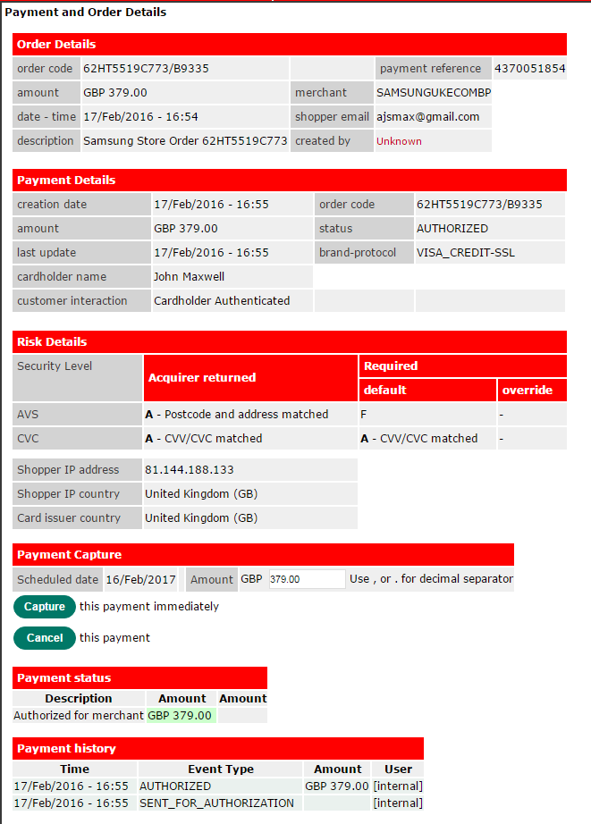

1. Sample WorldPay validation report

### WorldPay Risk Setting Matrix

The data validated by the WorldPay process includes checks on the Referral Lists, Velocity Checks, Shopper Session Checks, Consistency Checks and Post-Authorization Checks. A WorldPay scored of 100 or above will result in the order failing authorization and it will be rejected and the order status set to Declined.

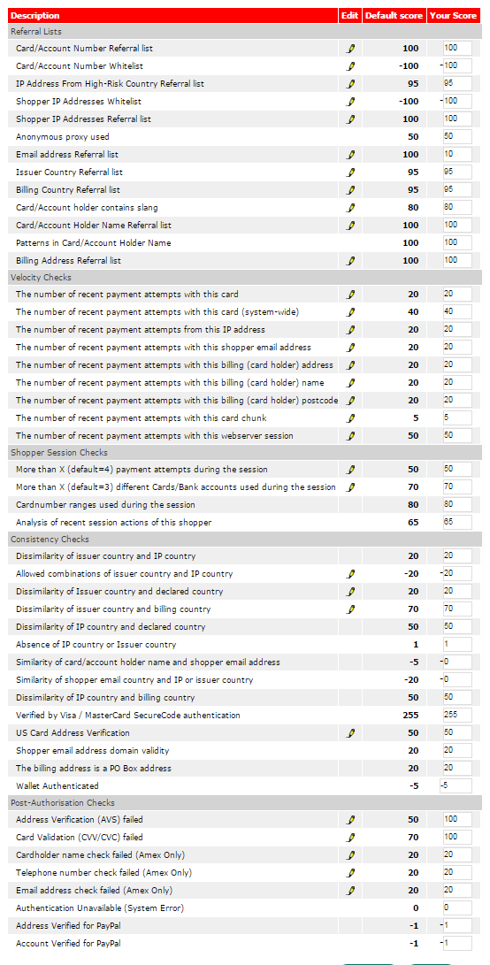

1. WorldPay Risk Setting Matrix

### Risk Guardian validation authorization

The following is an example of the Risk Guardian validation authorization for an authorized order:

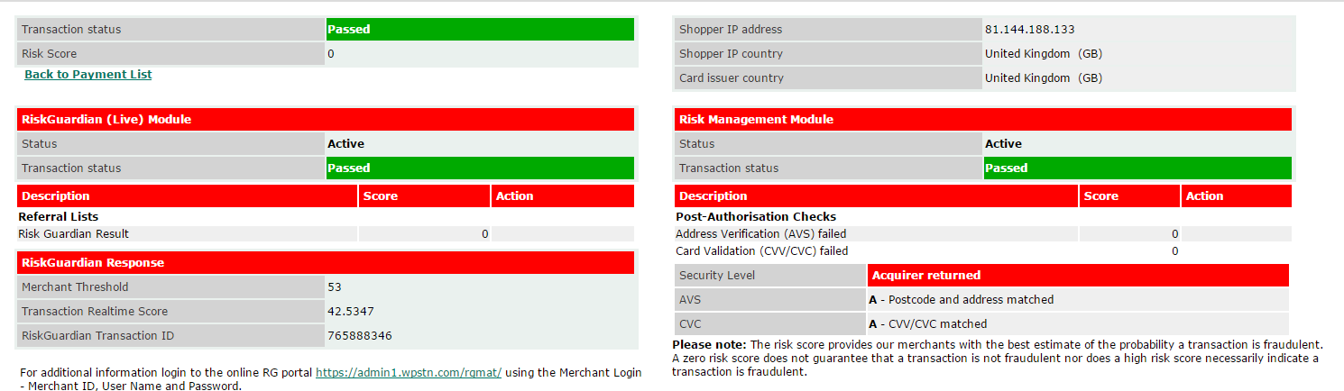

1. Risk Guardian RG Score example

# Payment Management

Payment management is straightforward for orders processed with PayPal or Credit cards, but bank transfers required manual intervention by back office staff (Nathalie Plessier’s team). The payment methods supported are:

* Credit cards and debit cards (WorldPay),
* PayPal, PayPal Credit (PayPal),
* Bank Transfers (no validation, pay before shipment).

1. There are three payment flows:

* **PayPal**: customer is redirected to PayPal site and enters data as requested, including delivery address and contact details. If order passed their validation, PayPal returns transaction ID and delivery information to Sequel; monies are transferred. Order is moved to fast track order dispatch for hard stock allocation, pick and pack and ship; order is shipped.
* **Credit/debit card:** Pre-authorization code generated at Payment Gateway validation pass state by WorldPay, which puts a soft hold on funds for 3 days (although no money is taken) for total amount of order plus AVS (additional 10% to cover shipping variances), Sequel puts ordered stock on a soft allocation; after passing fraud checks, the Dispatch Note is created, stock allocation moved from soft to hard allocation, and credit/debit payments taken as stock is leaving inventory control (at shipping point/courier ownership transfer point); order is shipped.
* **Bank Transfer**: Full payment in advance via bank transfer. Stock is not released until full payment has been received and reconciled by financial reconciliation process (performed exclusively for Samsung by Kameron), at which point the order is processed with either the Process button, Process All, or Check all buttons selected for the order or batch of orders, resulting in order set to status Processed, triggering a dispatch note creation, hard stock allocation, and pick and pack and ship processes occur; order is shipped.
* Cancelling payments (i.e. pre-authorisation) – If order is not completed (i.e., the order is stopped before payment charge), regardless of a pre-auth, no monies have been taken so no refund required (pre-authorization does not take money, it places money on 3 day hold only).
* If an order is returned for refund, no actual payment cancellation takes place via Sequel Order Management, it required back end financial reconciliation processing after several steps have transpired. Returns are credited and refunds processed by financial reconciliation, Kameron - Samsung financial services exclusively.

# Order Management

## Definition

Order Management is performed using the Sequel interface. Order management entails the processes required to bring orders from creation through to shipping to the customer. Most orders are entered correctly and have no issues. These orders move through the processes quickly, without customer service agent intervention with the customer and require only auto-processed or batch processing and the standard internal fraud check.

Approximately 30% of orders required CS manual intervention to capture customer information, insert or correct payment details, clarify product information, or a problem that has arisen from payment validation or suspected fraud.

Orders fall into one of three types and are in one of seven statuses at any given time (only one status per order at a time).

There are several order flows for orders in this system; they vary based on events resulting from when the order is created, when the payment details are validated, and after the fraud checks.

* Note: There are several order “sub-statuses” that are assigned during order processing that trigger processes and top level order status change, and are part of the record as it moves through the system. Both Order status and order sub-statuses should be discussed and clarified and determined as relevant in the system going forward.

See the sections See 5.2 Order types and See 7.2 Order Status for listings and definitions. See: 7.3 Order Management Process Flow for information on how the order flows through the various processes towards shipping to the customer.

## Order Status

Order statuses are used to organize orders into manageable groups for internal and customer service processing. There are seven top level Order Status designations, with several sub-statuses that are added to the order as it progresses through the order process, these sub-statuses are not viewable by the customer or customer service agent, they are internal to the system and are retained as part of the order record in Sequel.

There are seven different top level statuses assigned to orders within Sequel each with sub-status designations that are assigned to augment with a more detailed reference for later BI analysis. Information regarding Order Statuses is provided after the table.

* At present, Order Status must be checked daily to ensure an order doesn’t remain in a state of HOLD for more than 3 days without customer contact/resolution, as it may result into claims from customers or an order cancellation, and it maintains stock on soft hold, which makes the stock unavailable for fulfilment of other orders. Orders can remain in a hold state for no more than 10 days, at which point the order status is changed to Cancelled. The order can be revived by a CS Agent, and is out into an order status of “Unprocessed” and follows the basic progress through the order system, including Payment Gateway and Fraud checking.
* This issue of order remaining on hold, manual checking for aged orders, and lingering order awaiting information, cc approval, or payment should be addressed with ongoing development plans and automated in an aging report or other device to free soft allocations as soon as reasonable.

Order status reference table legend:

|  |
| --- |
| Customer (Customer Service Agent action) |
| Credit card (Bank / Back office / Processing) |
| Product (Stock / Purchasing / Fulfilment /dispatch) |
| Other |

1. Order Status Table and Sub-status table:

|  |  |  |
| --- | --- | --- |
| Order statuses | |  |
| Reference | Status | Definition |
| S1 | Not processed | These are all orders which have cleared payment gateway but not passed the fraud check processes. |
| ? | Un-Processed Pre-Order | These are all pre-orders which are ON HOLD waiting until stock is ready for dispatch; once stock is ready, these order’s status is changed to “Unprocessed” and are processed and dispatched first, before any other orders for this Product ID. |
| S2 | Awaiting Info | These are all orders which require additional information from the customer because the order detail does not meet the business rules of required data and so cannot be processed without obtaining additional information. Orders remain in “Awaiting Information” status until resolved.   * There is currently no automatic aging process, but this should be addressed to assure that orders do not linger in this state and hold stock in a state of soft allocation. |
| S3 | Awaiting payment | These orders require payment before processing due to the payment method used (e.g., bank transfer where the order is awaiting payment funds transfer or for an order which is missing part of the payment (insufficient funds for PayPal or Debit card, or the addition of the VAT amount because the VAT number provided was not valid). |
| S4 | Awaiting CC auth | These orders have failed the payment authorisation process for credit or debit cards, or where an American Express payment is awaiting to be authorized by AmEx, and the order is on hold pending another payment method offered by the customer or authorisation from AmEx. Orders remain in this state until the payment validation issue is cleared or failing that, the order is cancelled by CS and the order status is changed to “Declined” with no further processing. |
| ? | In Process | Ordered which have passed the Payment Gateway and Fraud Check processes and are in process of dispatch (hard stock allocation), and pick and pack and ship. |
| S5 | Customer cancelled | The customer has decided to cancel the order. There are sub-status reasons codes which are entered after this action, when possible; see the Sub-status table for details. |
| S6 | CS Agent cancelled | The customer did not pass the fraud check and the order cannot progress. |
|  | Declined | The order did not pass the Payment Gateway and no other CC , BC or bank transfer was used to resolve the issue. |
| S7 | Declined (info incorrect) | The customer did not provide the required information and the order cannot progress. |
| S8 | Declined (suspected fraud) | The order did not pass the fraud check processes. |
| S9 | Expired | The customer did not provide the required details for the order to progress. Should the customer contact CS and request it, the order can e reinstated and will be treated as any other order. |

* Because Un-processed Pre-orders require a re-confirmation from the customer that they want to proceed with the order, there is a delay, caused by the customer communications exchange method, that can sometimes restrict the ability to follow the FIFO method rules stringently, but all pre-orders should be a priority order. This is a first come, first served method, insuring that customers who pre-order receive their item before those who do not and this FIFO order method must be maintained.

|  |  |
| --- | --- |
| Order Sub-statuses (AFI) | |
| Reference | Sub-Status |
| SS1 | VAT number either omitted or invalid |
| SS2 | Card details invalid |
| SS3 | Postcode omitted / Address incomplete |
| SS4 | Possible duplicate order |
| SS6 | Further faxed information / confirmation required |
| SS7 | Awaiting CV3 code |
| SS8 | Awaiting 3-D Secure authorization |
| SS9 | Awaiting confirmation of ship to card address |
| SS13 | Card declined at processing |
| SS14 | Account order exceeds limit |
| SS15 | Account on hold |
| SS16 | Invalid account number |
| SS17 | Awaiting confirmation of old order still required |
| SS18 | Awaiting confirmation of pre-order |
| SS19 | Awaiting confirmation of product substitution |
| SS20 | Issue relating to B-stock item |
| SS21 | ~~Awaiting phone tariff details from customer~~ |
| SS22 | ~~Awaiting acceptance of phone tariff~~ |
| SS25 | Awaiting acceptance of terms and conditions |
| SS27 | Requires product mapping |
| SS28 | Possible pricing error |
| SS29 | Other reason |

* Order status sub-statuses are used internally, and do not show on order inquiries, just order records in Sequel.

## Order Management Process Flow

The Sabre 1.0 Order Management application provides the functionality enabling Order Management Administrators to manage the required activities for order flow from order creation in a website session or with the Enter Order screen in Sequel, to the ERP for the pick and pack and ship procedures and order completion.

### Change Order Status – CS Agent

Order statuses are changed in the system as a result of automated actions and by direct manual changes by approved authorized CS Support staff (Nathalie Plessier’s team).

1. Using the Sequel master screen, select the Order Processing button (to be in order processing mode). Select from the various fields of data entry, pull down menus, to define the scope of the orders you want to view and process.
2. Select the Unprocessed tab.
3. Unprocessed Orders that meet your criteria are displayed; whether in bulk, according to selected criteria or combinations of display criteria, or for an individual order by order number, name, or address.

* If you want to process or examine a single order on this listing, double click on the order line and the order opens. (Note, if you do not have authorization to perform the action, the screen will not respond).
* If you want to process all orders included in the listing, do not select an order.
* An order must be opened in order to make changes to the order contents, e.g., change quantity ordered, cancel a line item ordered, or to add items, or change the delivery address or other data, including adding information, payment details, or authorization.
* Once the details are entered, the CS Agent can elect to process the orders individually or in batch mode for all displayed

1. The CS Agent has the option of processing orders by using the Check All button (used whether one order or for batch orders), which performs the fraud check.
2. For those orders which passed the fraud check, the Process or Process All button is selected, which will move the orders into “Processed” status, which triggers a dispatch note and subsequent processes towards shipping.
3. The CS Agent may select any one of the action buttons listed in the following table (see table: Table 5) Sequel Action buttons ) to enact that process.

### Order Approval – Order Manager

### Requirement statement

The Order Management application supports a flexible workflow for an order, i.e. the order steps available within the system can be configured to be in a specific order to meet the business trading requirements and business rules standards for a client or channel.

At present, the order approval process is heavily manual and performed by Nathalie Plessier’s team in France. This is an area where there can be improvement in time management, throughput assurance, automated financial reconciliation with formal checks and reporting, formal ageing processes with accurate reporting, and enhanced BI data capture and analysis, with automation and current software methods and abilities.

### Requirement scenarios

* The workflow order can be configured to be in any order for a specific client or specific channel (e.g. check order validation occurs before fraud check).
* The Order Management application can support a series of workflow steps which are used to view and manage order details. Function includes a multiple criteria search query, (Order status, Order reference number, Customer details, Product details, Order created date, and Order Status), and, based on search result returns, the Order Approval User can access the order details screen and will allow adding or changing data, changing order status, initiating 3rd party processes, initiating internal fraud check, and approving orders.
* In phase 1 there is no administrator screen to support the configuring of the workflow order.

### Initiate Fraud Check - Risk Management

The CS Agent displays the order or orders to be validation in the Sequel Order Processing screen, and select the Check All button. The gateway validation, Risk Guardian fraud check, and the internal fraud check processes are started. The system returns an RG score and any other information that results from the screenings and the CS Agent considers several areas of interest on the order and customer details to determine if there is any risk of fraud for the order. This is a manual process and performed on each order.

### Manage Orders with Issues – CS Agent

The master screen in Sequel contains a list of customer service actions that can be performed for orders:

|  |  |
| --- | --- |
| Action button | Description of Use |
| Fast Track | Used to fast track orders that do not need validation or fraud detection (re-orders), those orders that have passed fraud check, or those orders with issues that have been addressed by a CS Agent and required expedited service. This action button triggers a dispatch notice, invoicing, soft stock allocation, and a picklist. |
| Process | Used to process a selected order that has passed the payment validation and internal fraud checks and is ready for dispatch. |
| Process All | Used to process all orders displayed in the order viewing area with a single batch command; all displayed orders are ready for processing, having passed the payment validation and fraud checks and is ready for dispatch. |
| History | Used to display the order history for the selected customer (highlighted on the viewing list, or the searched for order). This information is used during the internal fraud check, to verify customer information with a successful order history against a new order. |
| Request Code 10 | Used to request an authorization code from American Express (AmEx), which provides merchant seller insurance against order fraud, for order total less shipping costs. When this option is selected, the CS Agent prints a paper version of the order data and calls AmEx to obtain an authorization code for orders that pass validation processes, and a rejection – no authorization code given - response, should the order fail AmEx validation. |
| Send Email | Used to send an email to the customer; a search box is contained on the pop up email window allowing the CS Agent to select from a list of preset emails. |
| Decline (fraud) | Used when the CS Agent determines that the RG Score and/or the internal fraud check score indicates that there is an unacceptable risk for fraud. |
| Decline (no contact) | Used when the CS Agent determines that the customer has abandoned the order, the order is in “Expired” status, and no further input from the customer has been made. After 10 days, they are deleted if no further customer response has been made. |
| Customer Cancelled | If the customer calls and cancels the order, the CS Agent can cancel the entire order or item(s) on the order, using the Sequel master screen. The reason the customer choose to cancel is recorded for back end analysis.(Note: at present, I do not know how the CS Agent cancels a line item, as it is a live system and I cannot perform much exploratory testing. My guess is that the order is displayed, the line to be cancelled highlighted, then some action is taken to delete it from the order, and the order record is rewritten to the database.) |
| Expire Order | When an order has been sitting in a hold state, with order status “Awaiting for information”, or “Awaiting payment”, or “Awaiting authorization” for 3 days without any response from the customer, the CS Agent will change the order status to Expired. Such orders can be reinstated with customer contact, and they are further processed like a new order. |
| Check All | Use this button when you want to auto-process all orders through  all rules of process. Depending if they pass the business rules and fraud check or not determines whether or not they are processed. Orders that pass have their order status changed to “In Process” and they move towards dispatch. |

1. Sequel Action buttons

* If there was a single order process flow, it would go here, but there are many. Think it best to discuss each as separate process with high level text explanation. Using the Sequel interface is difficult due it being a live system and so far, there are several areas where expected screen activity is not happening; areas are not greyed out or otherwise visually restricted, although the actions are not allowed without authorization. 
  + 1. Requirement statement
* **Requirement**: The Order Management application enables an order administrator to access data within the system to view and change order information to manage orders toward completion.
* **Requirement**: The Order Management application (via the Sequel interface) enables CS Agents to create a new order, reinstate an Expired order, add or change information on an order, cancel a line item on an order, and cancel an entire order.
* **Requirement**: The Order Management application (via Sequel interface) enables Order approvals Agents to approve, Decline or Cancel orders pursuant to the business rules and results of fraud check processes.
* **Requirement**: For the System Administrator to configure aspects of the system.

## Order Process Flow List

There are many order process flows within the system. The list is below. Within the normal flow of an order, there are several branches that require manual intervention as well as internal process completion and affect the order status and progression towards fulfilment and shipping. The following is a list of the various aspects of order management:

* Create order
* Website order creation
* Regular Order
* CS Agent order creation
* Regular Order
* Pre-Order
* Re-Order
* Correct/add Order details
* Change Order Status
* Returned goods merchandise (RMA) / Quarantine order
* Trade-in
* Order cancellation
* Cancel Line Item
* Cancel Whole Order
* Payment Gateway Validation
* PayPal transaction
* Credit card or Debit card transaction
* Bank transfer transaction
* Fraud check – 2 processes:
* Initiate 3rd party Risk Guardian process (CC and DC only)
* Initiate Internal Fraud Check process (all orders)
* Order Approval
* Send order to Invoice and Dispatch (i.e. ERP and warehouse manager)
* Manage back orders
* Allocate stock – link to Stock Orchestration module
* Check logistics status (i.e. warehouse and shipping status)
* RMA - Return Merchandise Authorization.
* Refund payment - Payment handling
* Items in yellow are TBD under advisement, pending input from David and Simon for scope in this series of documentation, more pertinent to HLD for Sabre 2.0.

## Create regular order – website

A regular customer order is created via the UK webstore “shop.samsung.com” and that URL interface is used to complete the customer journey, for orders that have no issues.

1. Customers can access the e-Commerce website “shop.samsung.com” one of two ways, open the Internet Explorer browser and enter:

* http://shop.samsung.com/uk/
* <http://www.samsung.com/uk/> and select the “Shop” button along the top header.

1. Customer can shop as a Samsung account member or as a guest.

* Customers with a Samsung member account can either log in immediately upon the landing page, “Log in” button pop up window, or wait until prompted at checkout, or can elect not to log in to their Samsung membership account.
* Customers can elect not to join Samsung shoppers club and can shop as an anonymous guest.

1. The customer makes product selections and adds items and/or services to their shopping basket. Once an item is put into the basket, an order number is generated and the order process begins. At this stage, the customer is in a “token session” and the order information is not in the Sequel data base. It is not written to Sequel until it has passed the internal fraud check process.
2. The customer elects to go to Checkout and confirm the items in the basket to be purchased. At this point the customer may:

* Make adjustments to the types of items to purchase and to the quantity of items in their basket. Changes made to either remove an item or to change quantities are reflected immediately in the order totals visible in the Checkout screen.
* Add a discount voucher or promotional code in the field provided (current limit is one voucher or code per order).
* Select the type of delivery for the order. Currently, there is only one type of delivery for an order available. Order delivery is no charge to the customer for all orders.

1. The Customer selects which form of payment to use from a finite list of radio button options. Options are Credit/debit card, PayPal, PayPal Credit, or Bank Transfer. We currently accept payment using the following cards: American Express, Maestro, MasterCard, Visa Credit, Visa Debit. We only accept UK registered cards and payment on these cards is collected on our behalf by WorldPay. As soon as the order is placed we request authorisation for payment from customer’s bank. This includes orders that are to be delivered on a specific date.
2. When the customer is satisfied that the order is ready for payment, the Checkout button is selected.
3. The customer is prompted to sign in to their Samsung account (if they have not already done so), and they can elect to sign in, elect to open an account, or elect to continue as a guest without any Samsung account information entered.
4. Whether the customer is signed in as a Samsung account or continues as a guest, the next page shown will depend on the payment selection they selected.

* If PayPal was selected, the customer is redirected to the PayPal login screen, where they proceed with their PayPal order processing as normal; PayPal will return to the merchant (shop.Samsung.com/uk) a transaction ID for each order that passed their authorization process, along with the delivery address selected by their customer.
* The PayPal customer has completed their purchasing journey and a Thank you screen is displayed providing them with their order number and an email is sent containing thank you verbiage, their order details, the order number and tracking information with a delivery estimate.
* If Credit or Debit card is selected, The Checkout screen displays prompting for billing and delivery information associated with the card number that will be entered next. WorldPay will validate the name, billing address, and delivery address information against the card number information on record using three processes (3DS, AVS, and CVC), which validate the name and billing address, and that the CVC number on the back of the card matches the name and number of the card.
* If Bank Transfer is selected, the same Checkout Billing screen as credit/debit card displays. The information is not validated against the bank records, because bank transfers are pay up front, and no payment validation process is required.

1. The customer can elect to have the order sent to the same address as that of their billing address of record, or can have the order sent to another address by selecting one of two radio buttons. Sending an order to another address will prompt scrutiny during validation processes for both PayPal (unless the delivery address has been added to the PayPal delivery address list) and WorldPay, as well as during the fraud check processes (Risk Guardian and Internal fraud check).
2. The customer must select the radio button “I understand and agree to Samsung Terms and Conditions” to proceed with the order; they can optionally elect to receive marketing news, offers, and discount vouchers via email by selecting that radio button. Should they elect to receive marketing related materials, a tick box is selected in their order record and this will trigger automated emails during a marketing cycle process (I have no details about this process at this time. I believe this information is added to a marketing database containing the customer name and address and perhaps other information about their order or ordering history.)
3. The customer selects Place Order button and one of two screens displays:

* Credit/Debit cards: the Checkout Payment Details screen displays. This screen requests the card number, card holder’s name, expiry date (month and year) and the security code (the CVC on the back of the physical card). The customer has this last chance to cancel the payment or to complete the order payment by selecting the appropriate button.
* If the customer elects to cancel the order, the status is changed to Cancelled and the soft stock hold is released, and the order waits for 10 days until it is purged.
* If the customer elects to continue and pay for the order, the customer selects the Make **Payment** button and information entered is validated by WorldPay. World pay uses three validation methods, 3DS name and billing address check, AVS (Address Verification) and CVC (card verification code). The order must pass all of the validation processes in order to be “passed” and a pre-authorization code (pre-auth code) is returned to the merchant (Samsung) for the amount of the order plus 10% for credit/debit card to cover variances in shipping amounts. The pre-auth code is important, as it is a form of insurance against fraud; with a valid pre-auth code, the merchant is not responsible for the order costs, minus the shipping costs, should the order turn out to be fraudulent. With the pre-auth code, inventory is soft allocated to the order and no longer available for new orders.
* Bank Transfer: The Checkout Bank Transfer Payment screen displays. The customer in instructed to enter a reference for the bank transfer and then select the **Make Payment button**. **The reference field is a required field, although it will accept anything in the field, including a space. The instructions are vague. This reference string is added to the record and used during financial reconciliation (manually by Kameron), the process which confirms that the funds have been deposited into the merchant bank (Samsung’s holding bank, managed by WorldPay).**
* The customer can elect not to continue the order by selecting cancel order. The order status is changed to “Cancelled” and remains in the system for 10 days. It can be reinitiated by contact with customer service, which will change the order status to Unprocessed and the order will continue along standard processing through to shipping.
* The customer selects the Make Payment button to trigger a soft hold on ordered inventory and change the order status to “Awaiting Payment”. The “Thank you for using Samsung” screen displays and the customer journey is over except for two emails which are automatically sent to the customer, first a thank you, the second contains the Samsung bank details for bank transfer payments, the order number, and the order details.
* Per conversation with Taz, the verbiage on the Bank Transfer Check out screen was meant to be changed by Matt/Tony last week due to a large increase in customer service requests and a sharp decline in completed order and a sharp increase in abandoned baskets following the day when the code was changed to make this field required instead of optional in early February. The updated screen was to instruct the customer to enter a user defined reference that they would also use as the reference on their bank transfer instructions. In addition, the order number and Samsung bank details were to be added to this screen per Simon, and the emails need to be updated to reflect the change. – TBD pending bug fix update to software. 16/02/24 - NG

## Create regular order – CS Agent - Sequel

1. From the Sequel master screen, the CS Agent selects the Activities button (first on the left on the top row of buttons). A pull down menu lists the activities available: Enter Order, Enter Quote, Outstanding Quotations, My quotation history, Goods In, Purchasing, Stock Adjust, Order processing, Dispatch. CS Agent selects Enter Order and a new Enter Order window displays.

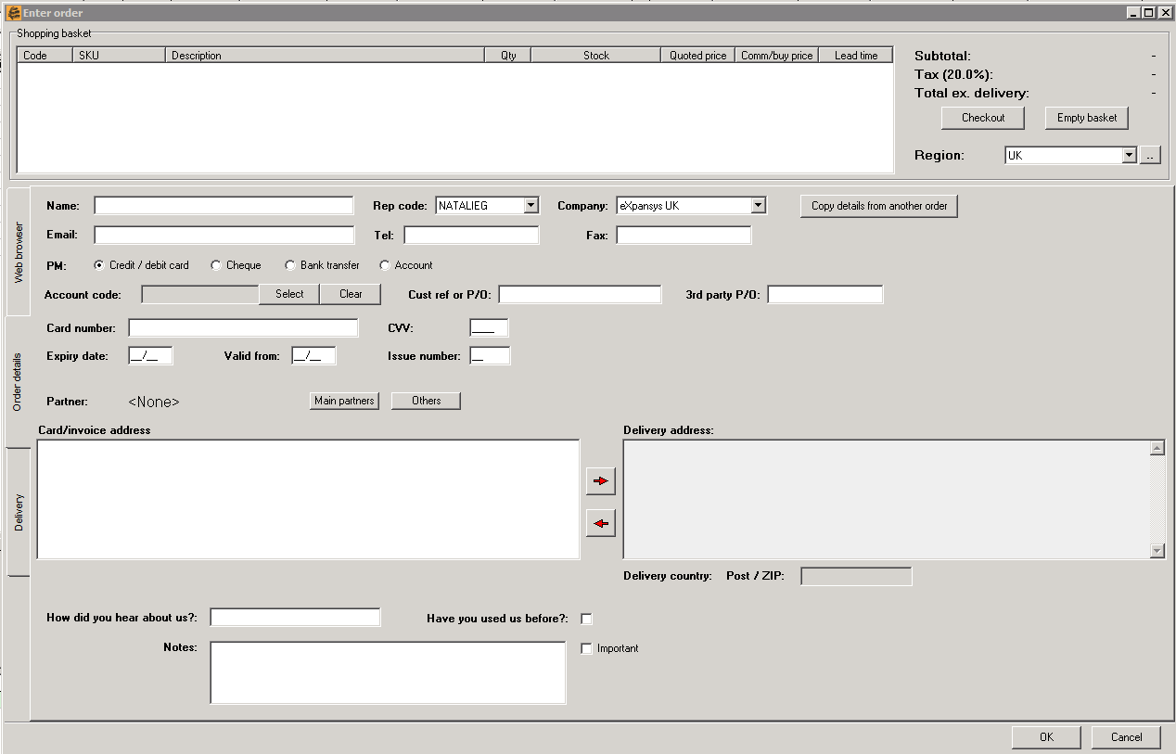

1. The CS Agent will enter the required information to fulfil the required information and the items the customer wants to purchase. Note the areas of the order entry screen controlled by side tabs, Delivery, Order details (selected for the above sample), and Web Browser.
2. Web Browser: Shopping basket, web site links for adding to basket (Note: This is not working for me at this time, I am guessing at how it works), Checkout button and Empty Basket button, Region (selecting the region will affect the amount of tax (VAT) that is charged on the order). After the agent selects the items to be purchased, either:

* “Empty basket” button is selected, and the basket is emptied of all items placed there, (effectively cancelling the order if no other items are added)
* “Checkout” button is selected, and the screen display the tab Order Details and all it’s fields.
* Order Details: Shopping Basket, Checkout, Empty Basket, Name, Rep Code pull down menu, auto populated with login name (CS Agent entering order), Company pull down menu (company of CS Agent entering order is default), “Copy details from another order” button, email, telephone, Fax, PM (payment method) radio buttons for Credit/Debit car, Cheque (this is not used), Bank Transfer and account (only the Bank Transfer and Credit/debit card button are used, along with PayPal (perhaps PayPal is “Account” no way to check at present via interface).
* Delivery: The delivery and billing address of the order are displayed. These are used by the CS Agent during the internal fraud check processes, along with the other logical areas where fraudulent information may be entered (different delivery address, different delivery zones, different names, multiple expensive items, former fraud activity or suspected behaviors, etc.).

Depending on the additional details of the order, the CS Agent may decide to fast rack the order, initial internal fraud checks (via Check All button), or process the order in batch or individually. It is a very fluid process and conditional on many factors including which agent is performing the processing.

## Create Pre-order – CS Agent – Sequel

Pending information - TBD

## Create Re-order – CS Agent – Sequel

Re-orders are made for returned merchandise, for those customers who request a replacement item instead of a refund for a product that they either did not receive or which required to be returned. An RMA is used to facilitate the returned merchandise and the data is included on the RMA report.

1. When a customer requires a re-order, the CS Agent who authorized the RMA will make notations on the original order record indicating that the customer requests a reorder of the returned merchandise.
2. When the RMA is processed, a notification is sent to the CS Manager (Nathalie Plessier) who will create a re-order using the Sequel Enter Order screen. The original order will be referenced, the order will be at no charge, and the order will be fast tracked through the system, as no payment validation is required and no fraud check, as it is at no cost.
3. Financial Reconciliation (Kamron) will process the reconciliation of all Samsung RMAs and re-orders.

## Cancel an order

This procedure details how an order is cancelled by an Order Processing or a CS agent. Orders can be stopped for three reasons:

* **Cancelled**: Customer has called to cancel the order before the item has been invoiced (in this case the order status is changed to Cancelled).
* **Declined**: The Process team has requested to cancel the order because it has failed a fraud check (in this case the order status is changed to Declined and notes are made to the order concerning the suspected/attempted fraud; this information will be considered should another order be attempted using similar details of customer, billing, or delivery address during the internal fraud check process).
* **Expired**: An order has lingered without customer response for required information for more than 3 days wherein the order status is set to Cancelled after 10 days, without any further contact from the customer, the order is deleted from the system.
* Note: This procedure does not cover the automated process of cancelling an order through the web store.

### Cancelled Order - Business Rules:

1. A cancellation status is made so orders can be stopped before an invoice has been generated (stopping payment from being made), and no further steps are required to fulfil the order.
2. If the order has been invoiced and payment has transpired but not shipped, then a credit note is generated to make a refund to the customer for the amount invoiced.
3. If an order is being paid “up front” (Bank transfer) and is cancelled after the monies are received or while the bank transfer transaction is in process, the order will be cancelled as “order cancelled” and when the monies arrive, a refund request will be raised for the amount of the bank transfer.
4. Despite this IT fact, upfront payments have to be refunded according to its characteristics not its classification in Sequel.
5. A refund request has to be issued by whoever cancels an order with an upfront payment method (as long no credit note has been issued in Sequel).
6. An order can only be cancelled if the order has not been marked as “shipped” or “part-shipped”. If the product has been shipped, then the order becomes a return and not a cancellation.
7. An order which has been partially or completely shipped it cannot be cancelled, only the unshipped items on a backorder can be cancelled.
8. If the product has not been shipped but has been invoiced, then the order becomes a refund.
9. Depending on the payment method and the order refunds are managed differently, if the payment method is:

* Credit card, when raising a credit note in Sequel, the credit card will be refunded for the same amount of the credit note which, by default, is a negative copy of the order.
* Bank transfer and PayPal (upfront payment methods), after raising a credit note in Sequel it goes directly to EXI and generates a refund request.

1. All refunds have to be completed within 14 days of a customer making this request.
2. If the cancellation is related to an order with an issue (i.e., order has been sent for pick and pack), before the credit note is raised in Sequel, a credit note must be raised in CTS to ensure that the product can be checked back into stock.
3. By default the refund should be made by the same channel through which the payment was made.
4. Upfront (bank transfer) payments can only be refunded in full.

#### Items for discussion for ongoing development:

* The web store function for self-cancelling an order can cause problems with ongoing dispatches, but this is not perceived as a major problem - no metrics available for how often this occurs.
* The system (Sequel) has never supported the generation of store credits for a customer to use on another order. Voucher could be an alternative as long as accountancy agrees on their use.
* The system currently enables an order which has been partially or completely shipped to be cancelled, this should not be possible.

## Send order to Dispatch

When an order has passed the payment validation and fraud check processes, it is ready to be processed. Processed status indicates that the order is ready for dispatch.

1. After the order(s) have been displayed in the Order Viewing pane of the Sequel master screen, they are fraud checked with Check All button; the resulting passed orders are ready for the next step, which is dispatch.
2. Orders which require further intervention by the CS Agent, are dealt with first, changing their status according to business rules.
3. Orders which are ready for dispatch are processed with either the Process button or the Process All button (for batch orders – all that are displayed). This changes the order status to “Processed” and triggers a dispatch note and subsequent processes towards shipping.

# Order History

## Order history: email address

### Requirement statement

The system administration can set up an order check where the customer’s email address is checked to see whether any previous orders have occurred for this customer.

### Requirement scenarios

1. Based upon email address against the order, and look up to see whether there are any previous orders in the Fraud Management application (in phase 1 this based upon deployment of the Fraud Management application i.e. all clients on UK deployment can share order history, but clients using the Hong Kong deployment would not see this order history).
2. Based upon the specific client, or based upon all approved clients – this is configurable for the client.
3. In phase 1 the user can only see a count of the number of completed orders and declined orders for the specific client, and approved clients (if configured).
4. In future phases: If the order history is for all approved clients then only the order value and order result and product and/or service type is shown – it does not show the specific product purchased or the name of the client. This is for security reasons.

## Order history: delivery address

## Requirement statement

The system administration can set up an order check where the customer’s delivery address is checked to see whether any previous orders have occurred for this customer.

## Requirement scenarios

1. Based upon delivery address against the order, and look up to see whether there are any previous orders in the Fraud Management application (in phase 1 this based upon deployment of the Fraud Management application i.e. all clients on UK deployment can share order history, but clients using the Hong Kong deployment would not see this order history).
2. Based upon the specific client, or based upon all approved clients – this is configurable for the client.
3. In phase 1 the user can only see a count of the number of completed orders and declined orders for the specific address for the client, and approved clients (if configured).
4. In future phases: If the order history is for all approved clients then only the order value, order result and product and/or service type is shown – it does not show the specific product purchased or the name of the client. This is for security reasons.

## Customer blacklisting & whitelisting

### Requirement statement

The system administration can set up a list of customers who are either blacklisted or whitelisted.

### Requirement scenarios

1. The system administration can add customers based upon email address to a blacklist or whitelist.
2. Order is checked to see if an email address is in the blacklist or whitelist.
3. If an order’s email address is in blacklist could result in a fraud score, a fraud alert being raised (depending upon the check configuration) or the order being automatically declined or quarantined.
4. If an order’s email address is in whitelist could result in a fraud score, or an order being automatically approved (depending upon the check configuration).

## Bin check

### Requirement statement

In phase one bin checks will not be completed, as it has an impact on PCI DSS and therefore needs integration and amends with the Picasso Payment Solution.

## 3rd party fraud prevention integration

### Requirement statement

In phase 1 integration with 3rd party fraud systems would be managed via a client extension.



# Order Status Change (Manual and Automated)

These are the process flows applied to customers’ orders whether the source is self service via the web site or via customer order entry. The pint of origin doesn’t make much difference for Regular orders.

Processes are managed by the ERP software and human intervention by a member of the Order Processing Team, who are in charge of reviewing, validating, approving or declining all orders before the order is dispatched to the warehouse for hard stock allocation, pick and pack and shipping the order to the customer.

After the fraud check procedure is launched by a Processing agent those orders that pass without issues “auto-processed” and are fast tracked to dispatch and shipping. If errors are found, the order will be processed according to its order characteristics by a Processing Agent. See “Order Characteristics” for information on that term.

## Manage Pre-Orders

Pre-Orders are entered via…I am awaiting information on this function. TBD

## Manage Orders with Issues

At present, almost 30% of all orders entered through the web site have issues, usually with incorrect or missing data entered at time of order creation. These orders are not rejected initially, but rather are filtered to the CS department in an attempt to complete the sale. Orders with issues are designated with various statuses and remain in the status until resolution or 3 days without customer contact, at which point they are put into a status of “Expired”; such Expired orders can be reinstated by a CS Agent if a customer makes contact and provides valid data within 10 days; after 10 days Expired order are deleted from the system. The reinstated order status is set to “Un-Processed” and proceeds as would any other order, through the payment gateway authorisation process, fraud checks, through to dispatch and shipping.

## Order Cancellation - Cancelling Orders:

There are three ways of stopping an order, each have their own status in Sequel:

* **Expire** an order: this status means that the decision to stop the order because of a lack of information and/or no contact from customer to correct issues, decision made by Brandpath; the order can be reactivated by CS Agent, should customer make contact and provided required information. For example, if the order does not contain a valid email address, the order is changed to status: “Expired” and it is up to the e-Shopper to contact Brandpath to inquire about the order and provide a valid email address. If the order is reactivated, the order status is changed to “Unprocessed” and the initial validation process begins as with any other order.
* **Cancel** an order: this means that the customer has requested to stop the order before the order has been shipped. The order is changed using the Sequel interface and status: “Cancelled” is added to the order record and a reference code is attached to the order indicating why the order was cancelled. See the table “Order Cancellation Codes” for details. Depending on where the order was in the process, a refund may be required.
* **Decline** an order: this means that the decision to stop the order has been made by Brandpath due to the potential risk of fraud. Risk assessments are based on 3D secure validation screening, which provides pre-authorisation codes for orders that pass validation and a decline status for those with invalidated payment data, name and billing discrepancies, delivery addresses with prior fraud activity, or a history of problem orders. Order changed to status: “Declined”.

### Cancel whole order

Orders may also be cancelled by the customer using the web store, either by quitting the application before completing the order (resulting in a cancelled or expired order) or by clicking the “Cancel Order” button on a web page during checkout, or the order may be manually cancelled by a CS Agent because of suspected fraud or by customer instruction.

1. From the Sequel interface, a CS Agent will search for and display the order requiring manual cancellation.
2. The CS Agent will select the appropriate button for the cancellation action (on right side of master Sequel Order Processing screen):

* Fast Track
* Process
* Process All
* History
* Request Code 10
* Send Email
* Decline (fraud)
* Decline (no contact)
* Customer Cancelled
* Expire Order
* Check All

1. The reason code for the cancellation will be added to the order record and its order staus will change appropriately.

### Cancel line item on order

1. From the Sequel master screen Order Processing interface, a CS Agent will search for and display the order requiring cancellation.
2. The order must be in the status “Un Processed” and the CS Agent must have the order open on their screen before any changes can be made.
3. The CS Agent cancels a line of an order by clicking on the product line and selecting “cancel”.
4. The changes are saved and the order can be further processed as required.

# Returned Merchandise Authorizations (RMA)

When the order is sent to dispatch, a Dispatch Notice (Delivery Note to the customer) is created which triggers the creation of an invoice, a master Returned Merchandise Authorization (RMA) record, and the pick list. Once the order has been picked, a packing list is created and part of that packing list is the printed RMA document for the customer to use when desired.

The RMA created is a master document, which is unpopulated with merchandise SKU or Product Ids, but does contain order reference information. The order is delivered to the customer, and should an issue arise which warrants a return, the customer contacts the ~CS department as instructed on the RMA. The RMA is required for all returns. It will allow the merchandise to be received at the distribution centre, scanned and credited against the order shipped, resulting in a refund or re-order, depending on the customer decision. \the returned goods are put into quarantine and returned to the MOR.

1. The customer contacts the CS department per the instructions on the RMA. Notations are made on the order record indicating an RMA is forthcoming.
2. The RMA will contain the instructions for the customer to follow, and the RMA return address document is put in the clear plastic shipping document pouch attached to the shipping box. The customer ships the container back to the distribution centre.
3. At the receiving dock at the distribution centre, the shipping pouch is opened and the RMA scanned by the receiving clerk. The return has been authorized and so the return process begins in one of two ways: refund or re-order.
4. The box is opened and the item(s) contained in the returned goods are identified and scanned for SKU code and those SKUs returned are added to the RMA master record. The customer can return either the entire order or one or more line items on the order.
5. The RMA will result in a refund or a re-order of the returned product, depending on the customer choice.

* If the customer requests a refund, the completed RMA receiving process triggers a request for a CSS credit to the customer using the same payment method used to pay for the order. This information is contained within the order record. The financial reconciliation agent (Kameron) will create the refund and send a memo to Samsung with the details of the return.
* If the customer wants a replacement item, instead of a CSS credit being issued, a CS Agent (Nathalie Plessier) will create a re- order in Sequel using the Activity/Enter Order screen, reference the original order, and there is no charge to the customer. The order will flow through the system as a fast tracked order (no validation or fraud required as no cost) through to pick, pack and ship.

1. The returned goods are entered into ERP/Sequel as returned goods and put into quarantine. Returned goods are never received into general inventory. The original order will contain notation of the customer’s decision to accept a refund or a re-order. This information is used by the financial reconciliation team to balance the no-charge order against the original order.
2. Yugen is notified of returned goods and a pick up order is generated to ship the goods from quarantine and back to the MOR.

# Trade-Ins

### Requirement statement

The site offers a Trade-In service when purchasing a predefined product, as promoted. Once the product condition has been selected and the Shopper accepts to receive a cheque for the value listed they are taken to a product purchase page.

### Requirement scenarios

There are two types of trade-in offers, Galaxy S6 range and Gear S2Product listings (with filter options) and Product Detail Pages, both are driven dynamically with content updates.

The product listing page:

* Is easily accessible, e.g. through links on the homepage, or from the menu.
* Shows key information to entice the customer to either view more details, or purchase the item (e.g. product image, name, price and teaser description). The filter options:

#### GEAR S2 TRADE IN

Trade in your existing Gear watch and we'll send you a cheque when you order your new Gear watch.

Select your existing watch and tell us what condition it's in to find out how much it's worth to trade in.

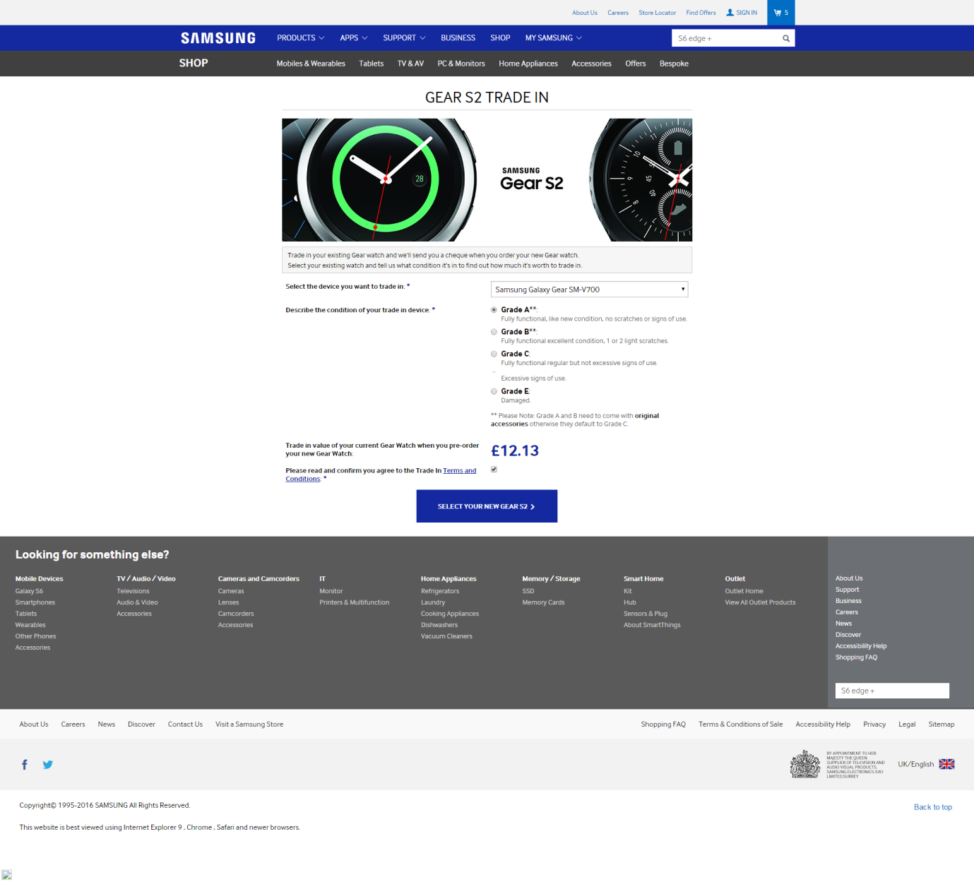

1. Figure 37 Example; Trade In Type 1 - Step 1;

http://shop.samsung.com/uk/geartradein/

Selecting the Terms and Conditions link opens a new tab, pdf document within an onscreen viewer with options to download.

TradeIn_TermsandConditions_20151029v2.pdf

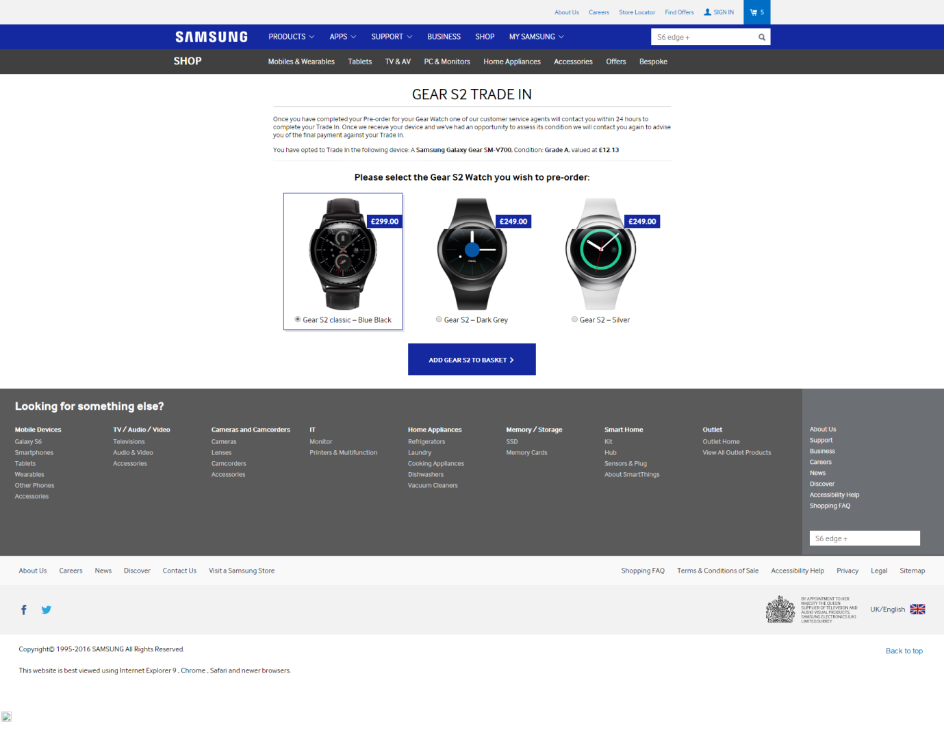

1. Figure 38 Example; Trade In Type 1 - Step 2

http://shop.samsung.com/uk/geartradein-select/

Once you have completed your Pre-order for your Gear Watch one of our customer service agents will contact you within 24 hours to complete your Trade In. Once we receive your device and we've had an opportunity to assess its condition we will contact you again to advise you of the final payment against your Trade In.

You have opted to Trade In the following device: A Samsung Galaxy Gear SM-V700, Condition: Grade A, valued at £12.13

Following product selection and add to basket, the shopper rejoins the standard checkout process.

#### GALAXY S6 TRADE IN

Trade-In Services are provided and managed by ShP limited. Trade in your existing smartphone and we'll send you a cheque when you order your new Galaxy S6.

Select your existing phone and tell us what condition it's in to find out how much it's worth to trade in.

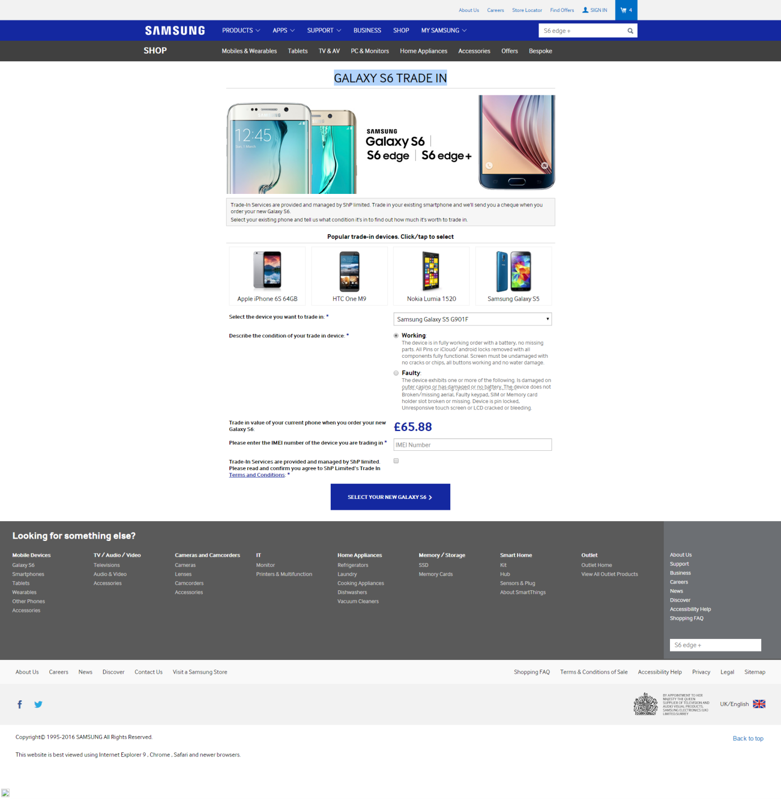

1. Figure 39 Example; Trade In Type 2 - Step 1

<http://shop.samsung.com/uk/s6tradein/>

Selecting the Terms and Conditions link opens a new tab, pdf document within an onscreen viewer with options to download.

TradeIn_TermsandConditions_20151211_v1

Once you have completed your order for your Galaxy S6, you will be sent a secure package and label to return your device. Once we receive your device and we've had an opportunity to assess its condition SHP Limited will issue your payment against your Trade In providing it’s graded accurately. In the event that our assessment of the condition of the device does not match the criteria selected by you on this website we will contact you to re-grade the TradeIn.

You have opted to Trade In the following device: Samsung Galaxy S5 G901F, condition: WORKING, valued at £65.88:

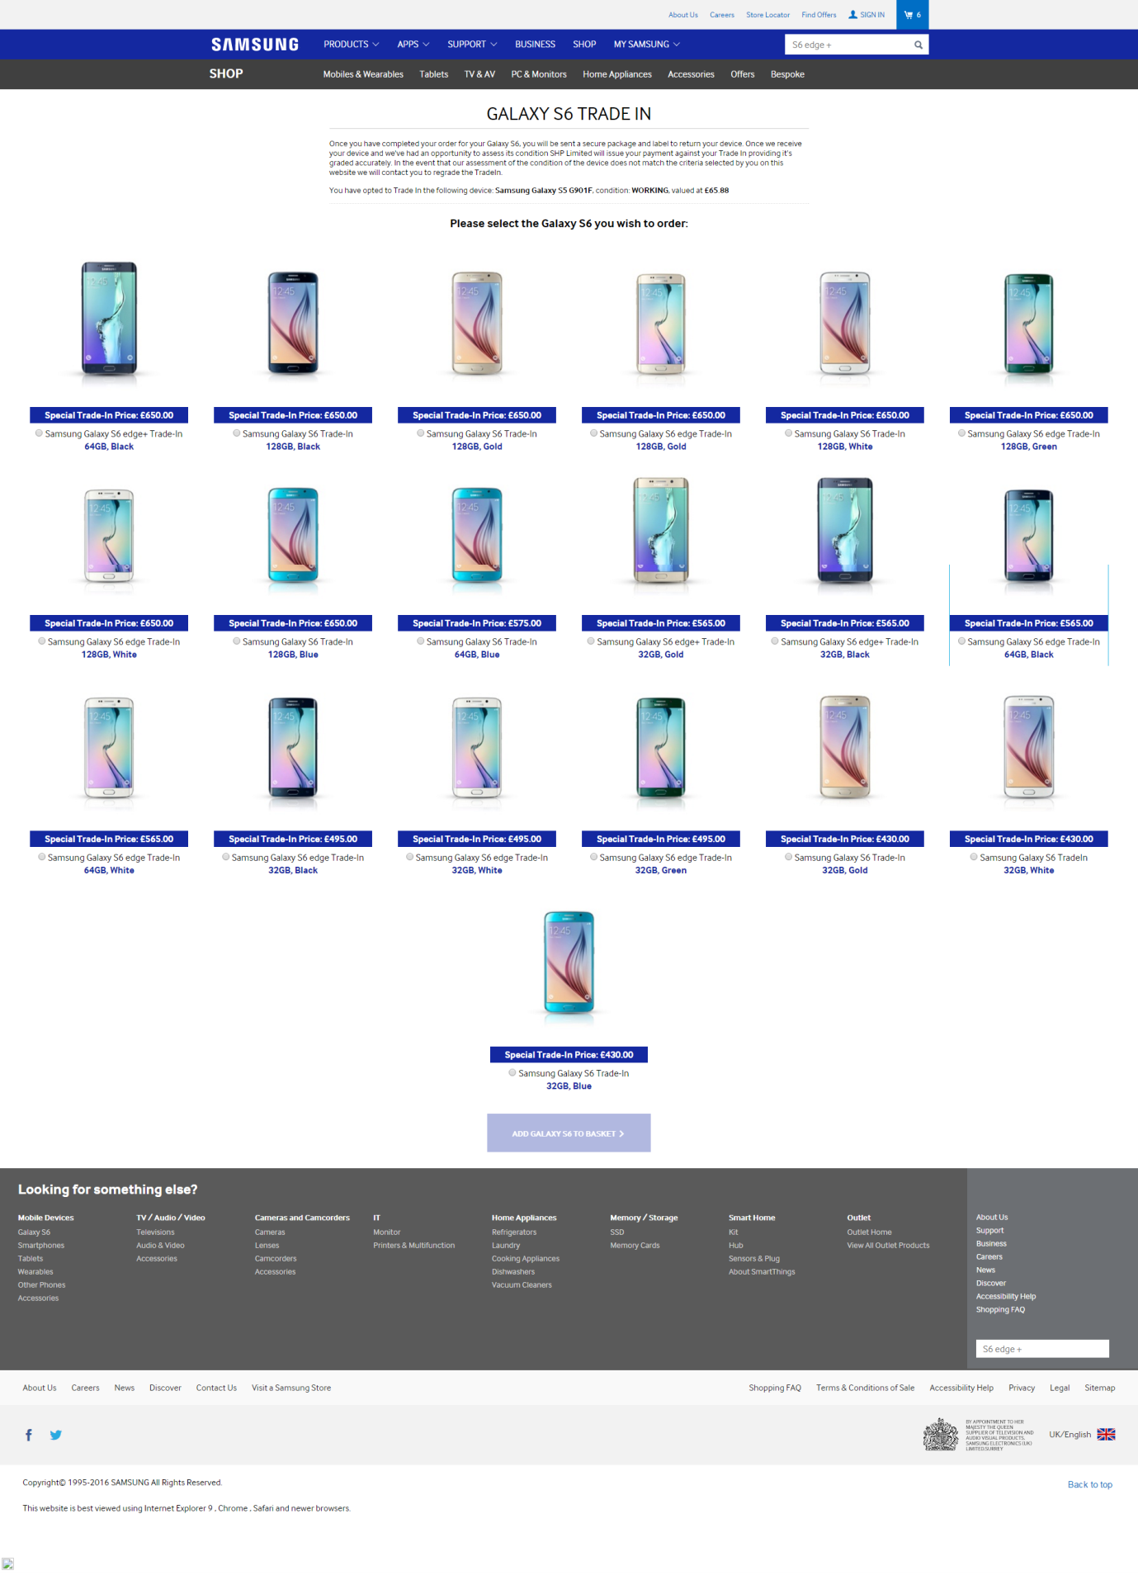

1. Figure 40 Example; Trade In Type 2 - Step 2

<http://shop.samsung.com/uk/S6tradein-select/>

# Reporting

### Requirement statement

The Order Management application will make available key order information to the reporting tool as part of its workflow steps.

### Requirement scenarios

1. Key order information will be made available to the reporting tool, via the Middleware.
2. There is no operational dashboard within the Order Management application in phase 1. At present, I have no v57isibility into the reporting function of the order management system. This would be back end operations, and possibly out of scope for nominal flow delivery.

# Preset Email Samples

From the Sequel master screen for order processing, select the “Email” button (on the right side) and a email popup window displays:

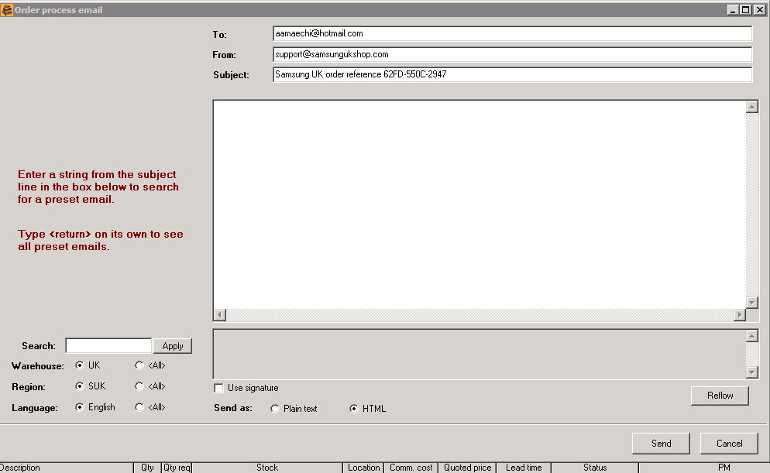

1. Sequel email popup window

The CS Agent can enter a partial string of text to locate the desired preset email to send to the customer.

List the available emails here:

# Requirement Specifications: Generic

## Generic requirements

### Requirement statement

The Sabre 2.0 site will adhere to the generic requirements as captured from Sabre 1.0 existing Shop website.

### Requirement scenarios

* The following generic requirements are supported:

1. The system will be monitored, as per:
2. System health check
3. System alerts
4. The system will support reporting, as per:
5. Strategic reporting – through Google Tag Manager/Google Analytics.
6. Reporting for Samsung as required through Omniture.
7. The Sabre 2.0 site will be compatible with:
8. The latest editions of Internet Explorer, Firefox, Chrome and the latest Safari for Mac (at the point of go-live).
9. The site will also be backward compatible with:

* Internet Explorer 9 and up.
* The site will not be tested against older versions of other browsers.

1. Android 4.1 operating system and later releases
2. A range of Mobile device types. (tbd)
3. Site must be a Responsive design. Whereby, for example screen sizing and content positioning are able to adapt to the viewing environment (device and viewer) in order to provide an optimal viewing and interaction experience.

## System integration

### Requirement statement

The Sabre 2.0 site will be integrated with the other BPC systems to both obtain and display information to enable the business processes to be completed.

### Requirement scenarios

1. The Sabre 2.0 site will be integrated with the following BPC systems:
2. Optimus Order Management Module – for cart, checkout, payment and order confirmation functionality.
3. Optimus Product Information Management Module – for products, services and pricing information.
4. Optimus ESOM Module – for information on stock levels.
5. Optimus eCommerce module – Maintain and publish pages
6. The Sabre 2.0 site will be integrated with the following 3rd party systems:
7. None planned

# Glossary

The Glossary is a long document spanning a wide range of terminology and too long for this document. Please refer to it at it’s location on the intranet: Bugatti/Optimus/Words and Terminology.

# Figures

Figure 1) Sample Sequel Order Processing master screen. 11

Figure 2) Sample Sequel Customer Service interface 13

Figure 3) Sequel Activities button 18

Figure 4) Sequel Enter order screen 18

Figure 5) Shop.samsung.com/uk home page 19

Figure 6) Shop.samsung.com/uk shopping basket 19

Figure 7) Samsung Membership Sign in Screen 20

Figure 8) New Samsung Membership Account screen 21

Figure 9) Shop.samsung.com/uk - Order Entry Checkout screen 22

Figure 10) Credit/Debit card checkout screen 22

Figure 11) Order validation process flow 41

Figure 12) Sample WorldPay validation report 46

Figure 13) WorldPay Risk Setting Matrix 47

Figure 14) Risk Guardian RG Score example 48

Figure 15) Figure 37 Example; Trade In Type 1 - Step 1; 70

Figure 16) Figure 38 Example; Trade In Type 1 - Step 2 71

Figure 17) Figure 39 Example; Trade In Type 2 - Step 1 72

Figure 18) Figure 40 Example; Trade In Type 2 - Step 2 73

Figure 19) Sequel email popup window 74

# Tables

Table 1) Versioning table 6

Table 2) Review Participants 7

Table 3) System User Types 14

Table 4) Customer Order data fields and descriptions 23

Table 5) Internal Check/validation matrix 45

Table 6) Order Status Table and Sub-status table: 51

Table 7) Sequel Action buttons 55

(End of document)